Marianna
Fond memories of a weekend getaway in Evanston -1971, I believe.
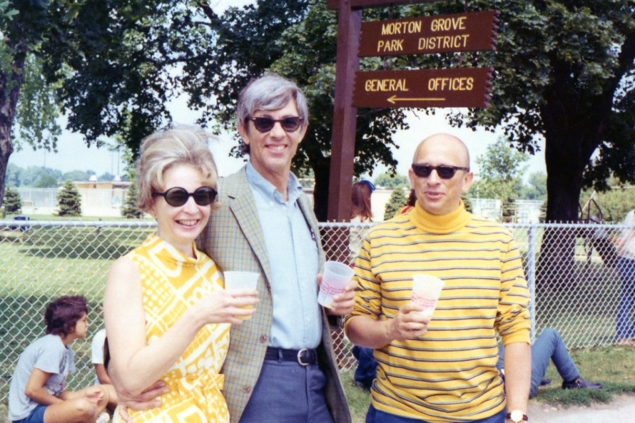
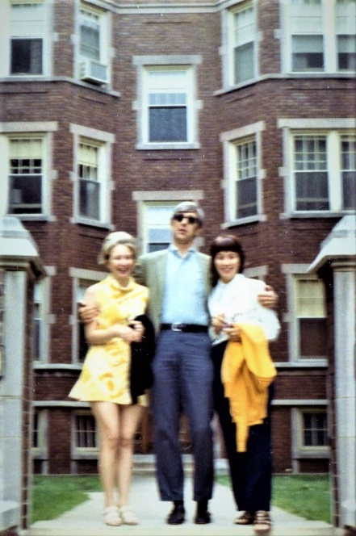 Sorry it’s blurry but couldn’t resist sharing the short skirt.
Gratitude for fun and challenging times together. Wishing a peaceful journey for you.
Zoe Barley

