The Ferguson ECOLOGY Team Video Night

Presents VIA ZOOM:

EXTINCTION
THE FACTS
With a million species at risk of extinction, Sir David Attenborough explores how this crisis of biodiversity has consequences for us all.

Thursday ~ February 16, 2023 ~ 7:00 PM

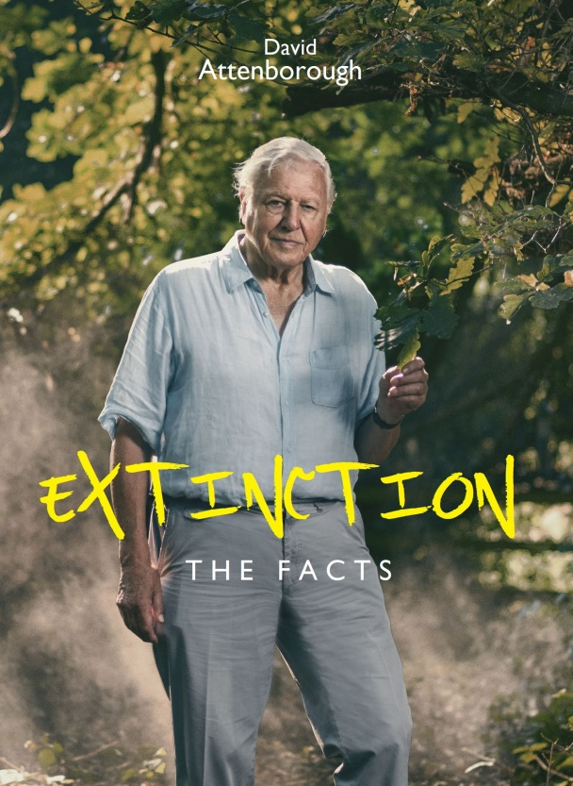

EXTINCTION: The Facts is a 2020 documentary film by the natural historian David Attenborough which aired on the BBC. Attenborough and academic experts comment on the sixth mass extinction, caused by humans, and the consequences of biodiversity loss and climate change. Humans are causing an animal and plant extinction rate roughly 100 times faster than has previously occurred. One million out of eight million species on the planet are at risk of extinction. It also suggests positive action which can be taken to halt or reverse these effects.
Conversation to follow the film
TO REGISTER FOR ZOOM LINK: https://bit.ly/FET16Feb2023
For more information: (314) 521-8418
carletonstock@aol.com

