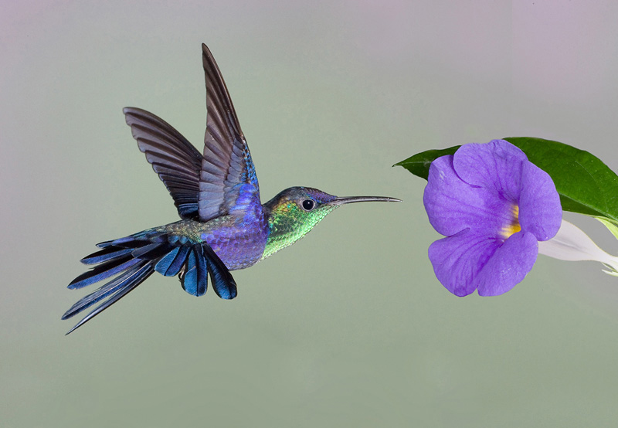

What the Heart Cannot Forget

by Joyce Sutphen

Everything remembers something. The rock, its fiery bed,
cooling and fissuring into cracked pieces, the rub
of watery fingers along its edge.

The cloud remembers being elephant, camel, giraffe,
remembers being a veil over the face of the sun,
gathering itself together for the fall.

The turtle remembers the sea, sliding over and under
its belly, remembers legs like wings, escaping down
the sand under the beaks of savage birds.

The tree remembers the story of each ring, the years
of drought, the floods, the way things came
walking slowly towards it long ago.

And the skin remembers its scars, and the bone aches
where it was broken. The feet remember the dance,
and the arms remember lifting up the child.

The heart remembers everything it loved and gave away,
everything it lost and found again, and everyone
it loved, the heart cannot forget.

