West Capitol Hill Neighborhood
Climate Action Forum

Saturday, September 21, 2019, 9:30 AM - 2:30 PM
Our Savior’s Lutheran Church
915 East Ninth Avenue, Denver, CO 80218
Summary Document

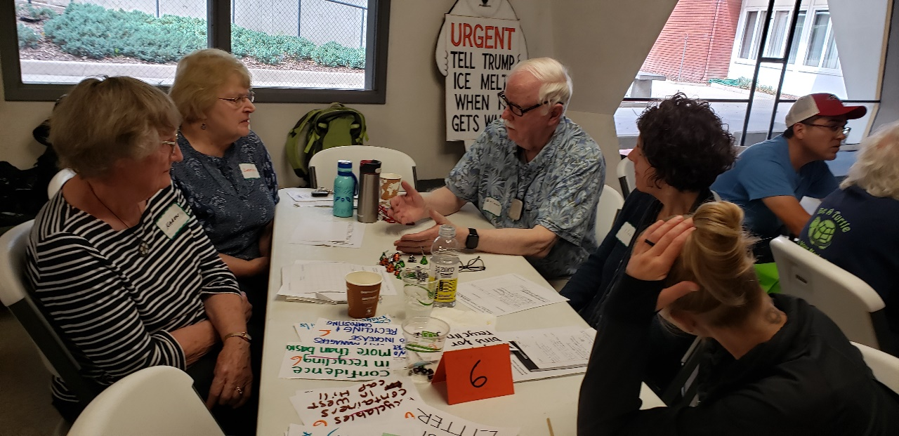

A program of ANCA - Denver
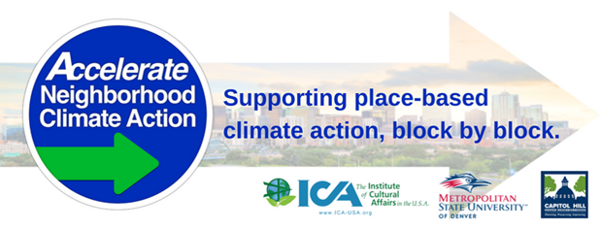
Organized by West Capitol Hill neighbors

ACKNOWLEDGEMENTS

West Capitol Hill Neighborhood Climate Action Team
Bonita Bock Keith Singer
Linda Carlson Frank Tapy
Jane Fillmore Jan Tapy
Gerald Forney Doug Wheeler
Dorothy Ostermeier Dean Zessin
Jim and OliveAnn Slotta, ANCA Coordinators
ANCA Climate Action Organizational Partners:
Capitol Hill United Neighborhoods (CHUN)
Metro State University of Denver (MSU)
The Institute of Cultural Affairs (ICA-USA)
Accelerate Neighborhood Climate Action (ANCA) - Denver Team:
Fran Aguirre, Climate Activist
Libby Comeaux, Loreto Earth Network
Liz Goehring, Climate Activist
Taylor Moellers, Sustainable Neighborhoods Denver
Dawnisha Penny, ICA / ANCA Social Media Lead
Sherwood Shankland, ICA ToP Facilitator
Jim Slotta, Capitol Hill United Neighborhoods, Inc.
Dr. OliveAnn Slotta, ICA-USA & Metro State University
Dr. Richard Wagner, Metro State University
Sunny Walker, ICA Certified ToP Facilitator
Catherine Welch, ICA / ANCA Forum Coordinator
WCH Forum Facilitation Team:
Sherwood Shankland, ANCA; ToP Facilitator
Sunny Walker - Documentation
MSU Student Assistants: Raul Rodriguez and Rachel Towbin and Paul Clark

Special Thanks for individual and organizational support:
Anonymous - Our Savior’s Lutheran Church
Battery Giant
Gerald Forney & Irene Ludwig, Our Savior’s Lutheran Church
Mountain Breeze Heating and Air, Inc.
Thrivent Financial Service

FORUM ATTENDEES:

- Abood, Tom: tabood@comcast.net
- Bock, Bonita: BonitaRB@aol.com
- Bowen, Tim: jati2288@yahoo.com
- Carlson, Dawn: dawncarlson51@gmail.com
- Carlson, Linda: linsimon@comcast.net
- Close, Judy: urclose2me@aol.com
- Close, Tom: urclose2me@aol.com
- Connett, Melody: melody.connett@gmail.com
- Ellis, Katherine: katherellis@gmail.com
- Forney, Gerald: gerald.forney@gmail.com
- Frank, Jerry:healing.reverence@gmail.com
- Fillmore, Jane: janemariefillmore@gmail.com
- Fulton, Mary: maryfulton@comcast.net
- Gall, Duane: duanegall@aol.com
- Gall, Jean: duanegall@aol.com
- Hall, Cornelia: corahall2001@yahoo.com
- Harrison, Jay: harrisonfeh@aol.com
- Holder, April: apeholder@icloud.com
- Kjeseth, Hisashi (Email not available)
- Knudson, Delmar: delmar1@mac.com
- Lennon, Kathleen: lennonkg@gmail.com
- Lettow, Marty: martylettow@mac.com
- Levy, Micah: mlevy8@studentcccs.edu
- Meeks, Mark: mkenosha@aol.com
- McGeath, Sally: smegeath@gmail.com
- Molstad, Janet: jati2288@yahoo.com
- Nassen, Elaine: redyfox45@gmail.com
- Newman-Lee, Jeff: jeffneumanlee@msn.com
- Nunn, Leah: leahrnunn@yahoo.com
- Ostermeier, Dorothy: dorothydenver@msn.com

- Porter, Barry: barryporter@gmail.com
- Ramsey, Baird: jlar1513@gmail.com
- Ramsey, Janel: jlar1513@gmail.com
- Requist, Jena: jrequist@aol.com
- Rethiger, Norris: norris.rettiger@icloud.com
- St. Peter, Theresa: (for Chris Hinds) teresa.st.peter@denvergov.org
- Taczosky, Romaine: romainetada@gmail.com
- Takahashi, David: the.dragons.be.here@gmail.com
- Tapy, Frank: franktapy@comcast.net
- Tapy, Jan: franktapy@comcast.net
- Schofield, Karleen: (No email)
- Simon, Mary: (No email)
- Singer, Keith: keithsinger@comcast.net
- Smith, Kathryn: kathryn.smith.560@gmail.co
- Towbin, Rachel: rtowbin@msudenver.edu
- Uhl, Alva: alvauhl@msn.com
- Ware, George: Gware2@comcast.net
- Watson, Robert: (No email)
- Wheeler, Doug: wheels80212@aol.com
- Winter, Faith: (No email)
- Yigletu, Belew: belewy@gmail.com
- Young, Linda: (No email)
- Zessin, Dean: dkzess@gmail.com

ANCA Team members:
- Burnap, Parry: parrywburnap@gmail.com
- Slotta, Jim: JSlotta@earthlink.net
- Slotta, Olive Ann: oslotta@earthlink.net
- Shankland, Sherwood: sherwoodshankland@comcast.net
- Walker, Sunny: sunwalker@comcast.net

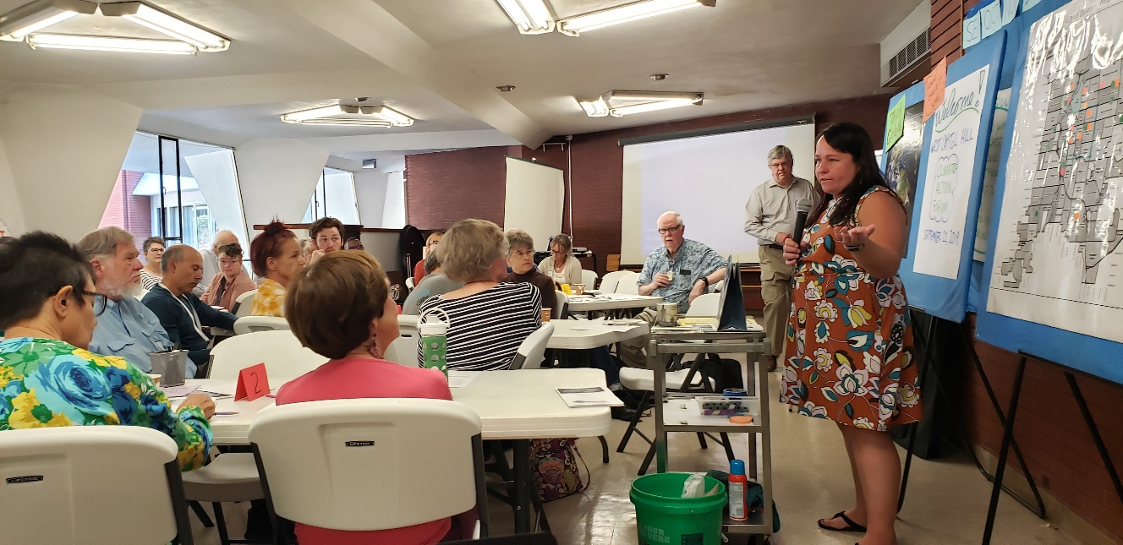
Colorado Senator Faith Winter in dialogue with the Climate Action Forum participants

FORUM OBJECTIVES:
- To refresh our view of opportunities for engagement in Neighborhood Climate Action
- To form Teams and Climate Action Plans for West Capitol Hill residents and friends in 2020.

AGENDA (actual)
9:15 Gathering, registration and networking – coffee and tea
9:30 Welcome, Objectives, Housekeeping, Schedule – Bonita / Rev. Marty / Sherwood
9:45 Greetings from Chris Hinds by Theresa (5 min.)
9:50 Introductions of Participants – shout outs and table talk
10:00 Presentation by Senator Faith Winter - Plans and Discussion (30 min.)
10:30 Presentation by Parry Burnap – Climate Action, Global Science perspective (20 min.)
10:50 B R E A K (10 min.)
11:00 Local Climate Action – our current initiatives in the West Capitol Hill neighborhood
11:15 Shared Vision for Climate Action in West Capitol Hill – Participant workshop – (45 min.)
12:00 Working L U N C H – Presentation by Jenna West-Heinz and discussion (45 min.)
12:45 Our Shared Vision – Plenary session (45 min.)
1:30 Climate Action Plans by Breakout Teams (30 min.)
2:00 Action Teams Report to whole group. (20 min.)
2:20 Reflections on the Day and Send-out – Bonita
2:30 Adjourn

After several weeks of preparation, organizing and promoting this neighborhood climate action forum we were expecting about 40 participants. At 9:30 we had 58 people in the community hall ready to go. Yea!! The speakers were enthusiastic, the participants were full or questions and ideas and the seven new action plans which they created are doable. Accelerate Neighborhood Climate Action and the West Capitol Hill organizing team are grateful for this strong showing of energy and commitment by the participants. Let’s reach every neighborhood in greater Denver!
“These are the Times and We are the People.!”
This document is a summary of the presentations, discussions and Action Plans created by the participants. The 7 new Action Teams will stay connected online and in person as needed for implementation. The organizing team and Action Plan Coordinators will work with the ANCA team to map out follow up meetings and communications. Thanks to all for a productive and inspiring event.

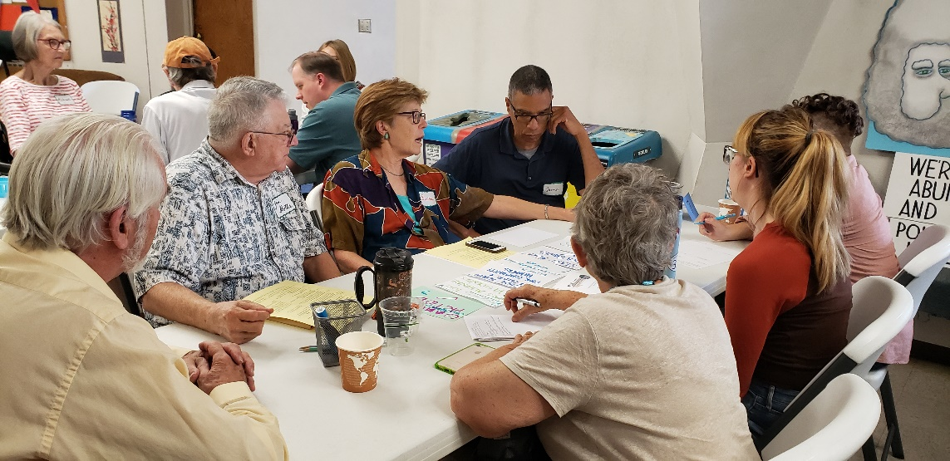
Climate Action Teams developing Action Plans at the West Capitol Hill Forum, 9-21-2019
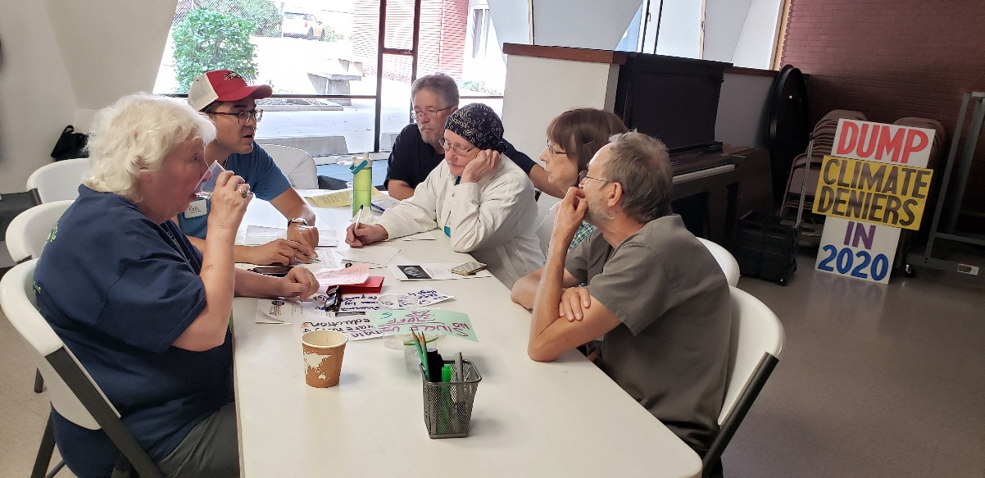
West Capitol Hill, September 21, 2019
Denver, CO Our Savior’s Lutheran Church
OUR SHARED VISION
What do you want to see that will reduce our carbon footprint the next two years across West Capitol Hill?
1  Global to Local: Carbon Reduction Behavior | 2  Climate Education | 3  Renewable Energy & Water Conservation | 4  Sustainable Transport | 5  No Single Use Stuff | 6  Waste Diversion / Recycling |  | 7  Collaborative  Community Action
- Adopting a lower-carbon diet  - Eat less meat  - connect each purchase with carbon footprint, build joyous routines for carbon off-set  - Living more simply confronting capitalism | - Change our thinking towards hope & solutions  - Education: “On Fire” book Naomi Klein  - Publicizing community success  - Idiot tax for climate deniers  - Ask self “how do my actions affect our world? Reflection  - Close in on 100% education, awareness on recycling vs. compost vs. trash at church including the cleaning staff | - Encourage &  subsidize xeriscaping  - Native grasses in City parks & private/public areas  - Engagement with solar gardens  - Solar gardens  - More solar roofs  - Affordable renewable energy  - Renewable energy | - Free public transport  - Promote NO 1-mile car trips  - Think before you buy a vehicle  - I-25 train down the whole corridor  - Improve bike lanes  - Reduce Driving car by 1 day /week  - Safe bicycling and bicycle storage  - Walk and bike more  - Better traffic engineering | - Single-use awareness & reduction  - Restaurant sign: straws by request only!  - No single use: napkins, bags (plastic)  - (State) ban on plastic bags in grocery stores | - Improved services for recycling and composting for buildings over 7 units  - Work with Property managers to increase recycling & composting  - Recyclables containers in West Cap Hill  - Confidence in recycling more than basics  - Recycle plastic litter;  - More efficient infrastructure for recycling  - More green bins (compost) | - Large clear bins for recycling  - Simplify and remove obstacles to recycle and compost  - Recognition / Rewards for good actions | - Demand a climate action statement from candidates  - Collaboration between CHUN & CHUM on climate  - March  - Solar garden  - Include people of color & poor community members  - Visible environmental voters  - Rebates for grass alternate in residences  - Start more ANCA groups

West Capitol Hill Neighborhood Climate Action Forum September 21, 2019
Action Plan # 1: Global to Local Carbon Reduction Behavior
Output(s): (Project description)  Individual and collective activities to reduce our carbon footprint | Outcome: (Project impact, intended results)  - Increased individual awareness of carbon footprint  - Increased comfort level with your own personal approach to carbon reduction
Strengths to build on:  - Work we’ve done individually  - Work the church has done collectively  - Tools, like “Carbon Calculators” that are already out there. (online) | Challenges to address:  - Impossible to be perfect  - Don’t be judgmental / dictatorial  - None of us enjoy public speaking and proselytizing
Implementation Steps | Who | Start Date | Finish Date
- Learn about your own carbon footprint | Each committee member | Today | On-going
- Apply that to the church as a location & group of people | “ | Oct 6 | Nov 30
- Find a sustainable personal balance / tone to use with yourself | “ | Oct 6 | Nov 30
- Explore your tone / expectations before and while talking with others | “ | Oct 6 | Nov 30
- Share what you have learned, start with church members | In messenger  In Forum | Dec 1 | Dec 1
- Consider where else (family, friends, work, others) we could share | Each committee member | Jan 12 | On-going
- Meet as a committee to check in | Whole committee | Nov 3 | Feb 23
Resources available or needed: | Coordinator: Keith Singer  Team members: Doug Wheeler  Judy Close  Jane Fillmore

West Capitol Hill Neighborhood Climate Action Forum September 21, 2019
Action Plan # 2: Climate Education
Output(s): (Project description)  - Book Club: ON FIRE! By Naomi Klein leading to Change of City Charter | Outcome: (Project impact, intended results)  - Educating others, raise awareness  - Reaching people in high-risers  - Change City Charter
Strengths to build on:  - Can work on becoming more hopeful  - Finding support of like-minded people | Challenges to address:  - Live around the city – virtual participation needed  - Adding people
Implementation Steps | Who | Start Date | Finish Date
- Schedule to meet - monthly | Janel | 10/19  10:30 AM
- Pick dates
- Invite Friends
- Invite others – high-rise dwellers
- Expand Recycling Services
- Contact Chris Hinds | Frank, Jan, Janel
Resources available or needed:  Books: ON FIRE! By Naomi Klein | Coordinator: Janel Apps Ramsey  Team members: Belew Yigletu  Frank Tapy  Dawn Carlson  Alva Uhl  Cora Uhl  Jay Harrison

West Capitol Hill Neighborhood Climate Action Forum September 21, 2019
Action Plan #3: Outdoor Water Conservation (vision input #3 and #8 combined)
Output(s): (Project description)  - Reduce water use in parks and yards | Outcome: (Project impact, intended results)  - Lower water footprint  - Acceptance of plants without grass
Strengths to build on:  - Water conservation = $$  - Good examples  - Existing garden tours | Challenges to address:  - Neighbors like grass  - Initial cost  - Incentive systems  - Needs city approval
Implementation Steps | Who | Start Date | Finish Date
- Research examples of low-water use
- Identify professional expertise
- Workshop with landscaper
- Organize garden / yard tour or demo
- Interview park staff
- Request landscaping changes from RNO and /or city government
Resources available or needed:  - Local expertise  - Stipend for professional expertise | Coordinator:  Team members: Rich Wagner  Baird Ramsey  Hisashi Amya-Ujeseth  Elaine Nassen  Micha Levy

West Capitol Hill Neighborhood Climate Action Forum September 21, 2019
Action Plan #4: Sustainable Transport
Output(s): (Project description)  - Walk and Bike more | Outcome: (Project impact, intended results)  - Better health  - Less carbon  - Cleaner air  - Less road rage
Strengths to build on:  - Denver / great climate  - Sidewalks for walking | Challenges to address:  - Traffic  - Weather  - Storage  - Theft
Implementation Steps | Who | Start Date | Finish Date
- Educate people about family friendly bike routes | BikeStreets.com
- Calculate carbon footprint
- Bicycle charity – donate bikes | Bikes together
- Join a walking or biking group | Denver Cruisers
- Advocate for bike lanes
- Promote incentives
- Bike registration
- Bike promoting car-free people (deductible)
Resources available or needed: | Coordinator:  Team members: Gerald G. Forney  Paul Clark  Kathryn Smith  Linda Young  Jena Requist

West Capitol Hill Neighborhood Climate Action Forum September 21, 2019
Action Plan # 5: No Single Use
Output(s): (Project description)  - Addressing local restaurants single use items: straws, take-home containers, beverage containers and take-home bags | Outcome: (Project impact, intended results)  - Move to non-plastic sustainable alternatives” paper straws, compostable / recyclable containers, paper bags  - Reduce Plastic Use
Strengths to build on:  - Personal relationships with businesses  - Positive public feedback: reviews, social media  - Patronize establishment  - Showcase them as role models | Challenges to address:  - Talking to people in power: managers, owners  - Addressing cost  - Training an education of staff  - Receptivity
Implementation Steps | Who | Start Date | Finish Date
- Refine an “elevator speech” | All | 9/23/19 | 10/7/19
- Determine restaurants in neighborhoods | All | 9/23/19 | 10/7/19
- Make list of target specific restaurants | All
- Create a brief document to leave with owners | All
- Determine who the restaurant owners / managers are…leverage relationships | All
- Determine best time to approach schedule appointments | All
- Reward positive responses and behavior on social media etc. | All
Resources available or needed:  - Printer  - Paper | Coordinator:  Team members:  Duane Gall 303-929-9718  Jan Tapy 303-377-8215  Jan Molstud & Tim Bowen 303-355-5034  Melody Connett 303-522-9388  Raul Rodriquez 303-990-1995

West Capitol Hill Neighborhood Climate Action Forum September 21, 2019
Action Plan # 6: Expand Waste Diversion Opportunities
Output(s): (Project description)  - Expand Waste Diversion (recycling & composting) Opportunities in Capitol Hill | Outcome: (Project impact, intended results)  - Increase choices, opportunities and volume of recycling and composting
Strengths to build on:  - High level of interest  - Existing recycling and composting efforts | Challenges to address:  - Providing specific and updated information to all apartment /condo residences – include for new people  - Getting more people to commit to waste diversion  - Convincing building management to get on board and not increase prices too much
Implementation Steps | Who | Start Date | Finish Date
- Work with property management companies: Apartments, Condos, | property managers,  city govt., CHUN
- Ask ANCA to organize building / neighborhood meetings; team up with neighbors train the trainers | ANCA,  interested neighbors
- Post lists of what and what not to recycle – be specific, regular basis | - Property mgmt.  - Waste companies  - Tenants
- Take steps to change the Denver charter re: recycling | - City council  - Voters  - Neighborhood groups
- Make info / resources re: Waste Diversion to neighbors | - Neighborhood groups  - Property mgmt.  - City government
- Create neighborhood recycling centers / bins | - City council  - Waste companies  - Neighborhood groups
- Gather data re: recycling / composting | - From Denver city govt.  - Neighborhood groups
- Take action to create & expand recycling and composting opportunities in suburban and rural areas
Resources available or needed: | Coordinator: ___________ / Team members:  Karen May KFmay@juno.com  Dorothy Ostermeier dorothydenver@msn.com  Delmar Knudson delmar1@mac.com  Mary Fulton fulton@ECS.org  Leah Nunn LeahR.Nunn@yahoo.com

West Capitol Hill Neighborhood Climate Action Forum September 21, 2019
Action Plan # 7: Community Action
Output(s): (Project description)  - Voter ed.  - Climate-focused candidates,  - Collaboration  - Protest  - Organizing at home & in neighborhoods | Outcome: (Project impact, intended results)  - Collaborative Action  - Candidates: Statements vs. our priority
Strengths to build on:  - Educators,  - Organizers  - Board member  - Legislative committee chair | Challenges to address:  - Gardener’s seat  - Composting  - Inclusive representation
Implementation Steps | Who | Start Date | Finish Date
- Solar Garden – Congress Park | Gerry |  | Spring 2020
- Open up dialogue with policymakers; Action plan | George  Bonita | October 2019 | Feb 2020
- Compost Tour in Schools | April | TBD
- Expanding Networks  (ANCA / CHUM / CHUN | Jim | October 2019 | Sept. 2020
- Campus Outreach | Rachel | ASAP | Dec 2019
Resources available or needed:  - CHUN  - Taking Neighborhood Health to Heart  - Whittier Action,  - Auraria Campus | Coordinator: Bonita  Team members: George  Bonita Bock  Jim Slotta  Gerry  April  Rachel

West Capitol Hill Neighborhood Climate Action Forum September 21, 2019
Action Plan #______ :
Output(s): (Project description) | Outcome: (Project impact, intended results)
Strengths to build on: | Challenges to address:
Implementation Steps | Who | Start Date | Finish Date
Resources available or needed: | Coordinator:  Team members:

NOTES ON PRESENTATIONS AND GROUP DISCUSSIONS

- Welcome – Bonita Bock, Chair, West Capitol Hill Climate Action Team

- Greeting from Chris Hinds - Denver City Councilman District 10
Remarks by representative Teresa for Councilman Chris Hinds – spoke of Denver Climate Goals and signs of progress in climate action:
- Gore: renewable energy quickly becoming the industry people are investing in

- Tri-State (energy??) – shut down a Western slope coal-fired plant 3 years ahead of schedule.

- Forum Context - Sherwood Shankland, Facilitator
- Welcome to the West Capitol Hill Climate Action Forum. What a dynamic week we have had for climate awareness! Students striking worldwide yesterday and greetings from Greta Thunberg to the UN and to all of us - the challenge to listen to Climate Science and to move beyond talking to policy changes and to solid commitments to climate change mitigation. Inaction by this generation will not be forgiven. Our common future is waiting!

- Our language is moving from Global Warming to> Climate Change to> Climate Crisis to> Climate Emergency to> Climate Action. If this global movement is going to have staying power, it must to be locally anchored in neighborhoods, with VISIBLE signs – like compost piles, recycling bins, and barrels of used batteries.

- Action at all levels are important pieces, but the bedrock of an enduring movement is in our neighborhoods. Four years ago, my neighbor put up solar panels which inspired me to do the same, then 3 more families followed and now four more this year. Neighbors nudging neighbors is a powerful force fully within our reach to encourage local climate action.

- Think Globally, Act Locally… It’s time to take it to heart again.

- Participants at tables shared what they are already doing to reduce their carbon footprint.
For example: Solar gardens are less visible in the neighborhood, but just as important.

- Colorado State Senator - Faith Winter
- Every Sunday hiking and can SEE how different it is now than when I went as a child.

- You have to define the problem for people: every single year, our firefighters are having to fight longer and hotter wildfires. Just sent a lot of ours to California. Losing ski days, reducing tourism. Farmers can’t grow same crops as 20 years ago, so losing family farms. Important to look at the impacts YOU are experiencing in the state. Not enough to just say it’s real.

- THEN, talk about the urgency and the science, we have 12 years left – we need policy changes yesterday!

- Solutions, like you are going to be working on today. Psychologists are being trained now to help people deal with stress over climate change, children are staying awake at night over it, so it’s important to share solutions. Collectively we can solve it.

- Bill 1261 - plus an update of building codes. Also change in source of building materials, such as using US steel vs. Chinese steels. On building codes, no one is going to like. Next transportation. Biggest emitters in Colorado are cars. Did a lot last year at moving us to electric vehicles, but not much yet on public transportation. Talking about how to fund it. Can’t rely on gas tax in the future. It’s being used for electric vehicles. Questions of where to find the money elsewhere. Did a lot last year, AND this year focus on buildings and transportation.

- How to get involved to make a difference? 500 registered lobbyists and 100 senators. 70% of lobbyists represent corporate interests, so we REALLY need others involved. When YOU come to the Capitol and phone us or email us, it means 50x more than someone paid to represent the interests of their clients. WE can be just a loud and just as present. Committee hearings are important, but NOT for votes. So, right now, the Senate and House caucuses are listing ideas and with dots, to see what matters most. Reach out to them and say climate is important to you, because those decisions are being made NOW. Bills are written in Dec. Five bills for each person, and three must be done in December. THE MOST IMPORTANT TIME TO CONTACT THEM IS NOW!!

- THEN, in February and March, let them know what is needed and what you want because builders are making some hard anti-arguments. Talk to the developers, too.

- When you come to a committee hearing. Three conversations are happening at once. People get annoyed because often people are multi-tasking – the actual conversation in the room, people testifying and committee listening, #2 is on Twitter, and #3 is conversation between legislators by text. You can be in on all three of them!

- We are also speaking to transit authorities like RTD. On buildings, if retrofitting, then upgrade vs. everybody having to do it. PUC on table for a bill this year. Changes last year, working on how it gets implemented and who will be on the PUC. Q: could gas-powered lawn equipment be outlawed. BIG political issue (libertarian state, across the political spectrum). Working instead to incentivize what you want, vs. “you can’t have the bad thing.” Q: What about money for cities to make biking safer, so more people would ride them? Re: Water, she is NOT on that committee, AND we have a good water plan, environmentally friendly and underfunded. VOTE FOR CC. That will release funding.

- Proposition CC (compare Tabor where people get to vote on their taxes, but severely LIMITS governmental spending): says, in good times when economy is going well, don’t have to give it back.

- Gov Polis and Attorney General just joined the lawsuit for environmental protections. Many of Faith’s bills are to put locally in place the things Trump has rolled back.

- You can come and shadow her any time…a real opportunity to understand what’s going on!

Q: What can local people do to affect state policy – SHOW UP! Example, last year, 500 bills and 30 on climate. Right now, the most calls she gets are about taking action on guns. There is only so much bandwidth and political capitol. Yesterday the Climate Strike showed the urgency for action now. Build relationships with local elected officials. Then, they will listen to you, you become “their person.” Keep that urgency up on climate action!

- Parry Burnap – Climate Reality Leader, Denver (She will make her slides available!)
- Parry’s slides: recommended news sources Climate Nexus and NYTs Climate Forward
carbon calculator: http://www.nature.org/greenliving/carbon...? EPA has one too.

- Lots of great Denver organizations. Talk to your neighbors. Looks for solutions that bring joy, not suffering. For example, eating food from local market, riding your bike…We can head off the extra global heating that is occurring (equiv. to 400K Hiroshima size bombs daily) from burning fossil fuels, 20% of which remains in the atmosphere after 10,000 years. It does involve change. In 15 min./week we can make a huge difference.

- What struck you? We need to compare population growth graph with those other “hockey stick” graphs. Solutions have to bring joy – also have to bring employment and better satisfaction to consumers and profit to those doing the solutions (businesses). Investment capitalists putting long-term money into renewables vs. coal and fracking, etc.

- Recommendations:
- OSLC do the recycling for their senior housing next door
- SCRAPS – company where you can compost 3 gallons every month picked up on bicycles from Condo’s.
- Plant a tree, creating an urban forest.
- If you are a climate activist, people will become aware of it.
- J Slotta’s email from someone asking for items provided for farmers market and other locations.
- From a participant:
  - Rethink – your choices
  - Refuse – single use
  - Reduce – consumption
  - Reuse – everything
  - Refurbish – old stuff
  - Repair – before you replace
  - Repurpose – be creative, reinvent
  - Recycle – the Last option
- RAFT Colorado – collect things that don’t necessarily go to other recycles – what they collect goes to making art in schools.
- Re-affirm what an open heart and open ear you have in Councilman Chris Hinds. Never be afraid to call him or his office. City is looking at PayAsYouThrow (PAYT)

- Denver – Janna West-Heiss City and County of Denver Office of Sustainability

- You can get a score for your home (like mpg for your car) of carbon usage. Great resources re home energy support from the city and a lot on solar in particular.

- Resource library on the website: Love This Place Resource Library, for Individuals & Families, Businesses, and Neighborhoods. There are “how-to” guides put together by local neighborhoods.

- Sustainable Denver Summit – Dec 5th: make a commitment to action.
Certifiably Green Denver – a free sustainability advising service for Denver business community – patronize these businesses!

- Waste Diversion – See Food Recovery Hierarchy (meal planning is higher up than composting).
- City composting for individual family homes and apt buildings of 7 or less units.

- Sustainable Neighborhoods: see map. Capitol Hill is NOT on it (yet…)

- Mayor and Council Announce New Plan to Address Climate (August 26, 2019. It will contain the former Office of Sustainability.

- Mayor’s proposal for climate action - $40 million of budget for climate

- What We Can Do Here – see slide list.

- Connect with us online: many opportunities

Group comments and questions:
- Meal planning as an important way to act
- Building certificate program
- $2.9 million for EVs and needed infrastructure.
- Questions for her: what about the lights on in downtown Denver at night? There’s not an official requirement around it and a suggested policy. Will be working on it.

- Are you working on churches and buildings more than 7 units for recycling and composting? NO, in city charter prevented from doing so. Can get a company to do it for you.

- And also, the issue with growth of population and more high rises…

- $12,000 tax credit for buying an electric vehicle – state $7000 (rest from feds unsure after 2019)

- Are there adequate resources for accepting recyclables and compostables? YES, mayor is increasing the budget to do so. To increase that, may put a price on trash.

