‘Living on the Edge’
A celebration of the life of Ray Richmond

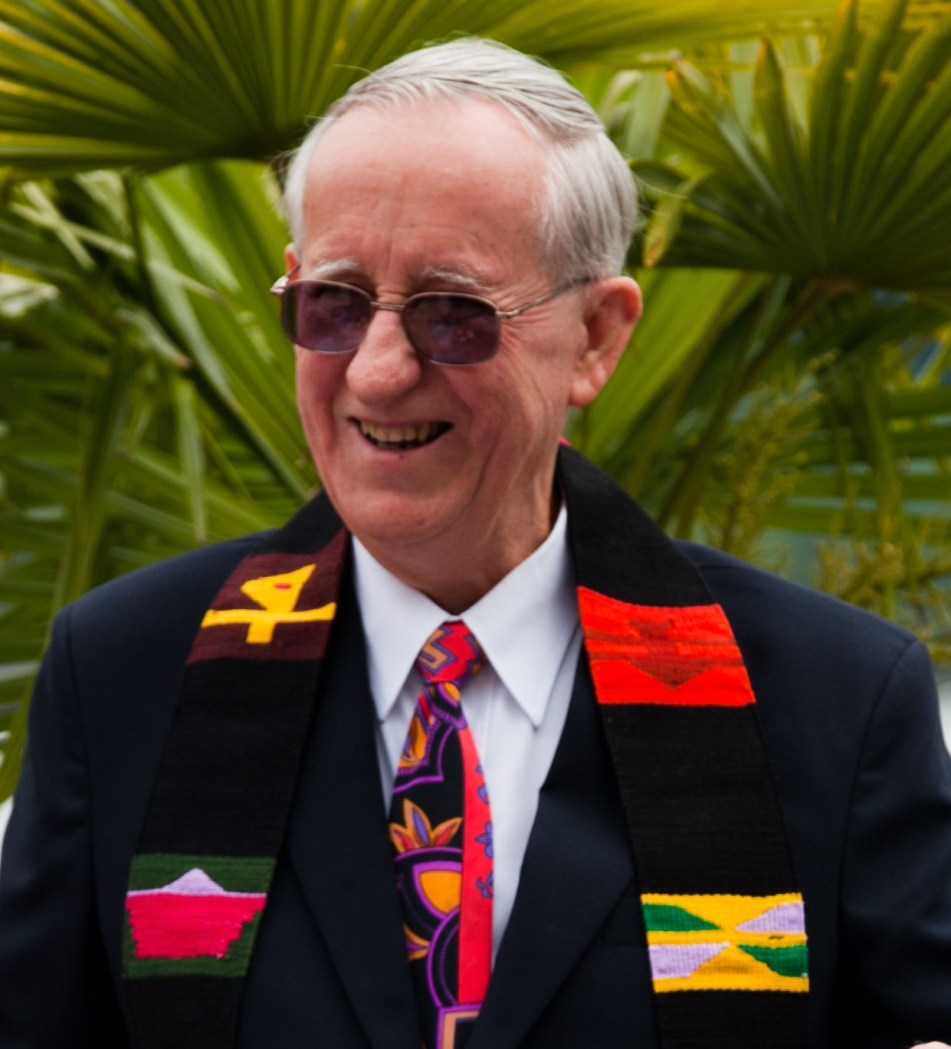

Family and friends are invited to a ‘Living on the edge’ party
at the Wayside Chapel
2pm on Sunday, 17 November
This will be a celebrative time of music, song and poetry with refreshments
**********
You are invited to bring something – a symbol, a piece of poetry or song to remember the difference Ray and Elaine made to the lives of so many!

We look forward to seeing you at the party!
Sandy and Karen, Kurt and John, with family and friends

