Remembering Sally Stoval
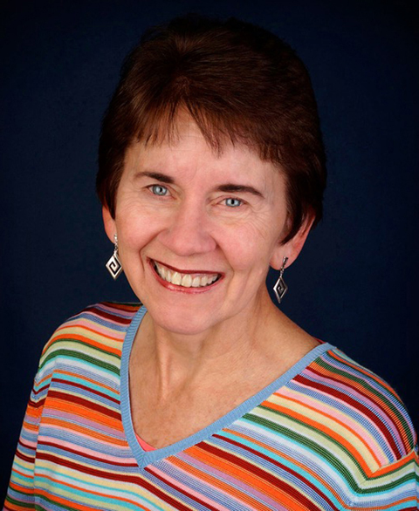
…on behalf of all of us who are struggling with this one taken so soon. Lynda
Sally Stovall was an amazing woman. She walked her talk as a founder of Green Community Connections and as a founding member of the One Earth Film Fest… both huge undertakings, and are successful, due in large part to Sally's work. Beret and Paul

I am shocked and saddened to hear that Sally has passed away. It was such a pleasure to reconnect with her, and you Dick during my time on the ICA Board of Directors. Her passion and exuberance was always reflected in her radiant smile. May you and her close loved ones find Peace in your grief. Joyce Sloan

Oh my, my, my… how our journeys fly, fly, fly. Sally’s death is a jolt. I had not known of her illness, so I was caught off guard by the news. Dick you have been so very lucky to have Sally as a spirit buddy in your ‘silver sneakers’ years. Her captivating smile invited conversation and beamed affirmation. She is greatly missed as I’m sure you already know. Blessings in these days of grief and reflection, and on the road ahead. Grace and Peace, Sherwood and Eunice.
"The new woman--what does she look like? Strangely enough, she doesn't look like anybody. We are never again going to be able to have one figure who holds for us what it means to be a woman. ... All kinds of new images are coming, but no single encompassing image. This is part of the complexity of the 20th century. ... If you want to know what the new woman looks like, just turn and look. She is seated right beside you. She is already here." LaDona Wagner (Donna McCleskey)
For me, Sally, like so many on this list, lived the journey and challenge of "The New Woman" that has so deeply affected our planet and energized our lives over the last 3/4 of a century. I am more than grateful. Celebrate and memorialize her life on Saturday. Sing loud songs from full and broken hearts, Eat together, flavorful and nutritious foods. Remember Sally well. Jim Weigel

We will remember Sally this weekend Dick and to all her dear family and friends, we send our loving sympathy. In peace and love, Isobel Bishop.

Dick, my heart is with you and all who knew and loved Sally. Blessings as you celebrate her this weekend. Love, Sunny

I was so sorry to hear of Sally's death. I stand with you as you celebrate her unique unrepeatable life. Joan Knutson
Dear Dick, I am so very sorry to hear of Sally’s passing. I mourn and also celebrate her full and creative life. God bless you. Nancy Trask

Dear Dick, I am surprised and saddened of Sally’s passing. Thinking of you and all your family relations as we celebrate her completed life. Elsa and Addi Batica
We join you and the family in celebrating Sally’s amazing life. I am grateful for the times when we were together and I got to know her humor and gentle determination. Jan Sanders
What a legacy Sally leaves in Chicago with her dedication to the ever expanding creation of the Environmental Film Festival for all of Chicagoland. This model was a real awakenment event for the many beyond the usual “preaching to the choir” in Chicago’s 77 neighborhoods, educating thousands over the several years. There are many who are looking at what Sally and you have done as a model for their own communities. She has demonstrated a very Trans-Establishment pioneering miracle. I’m so grateful that I had a chance to meet and tour some of Chicago’s gardens with her last year when I was in Chicago. Our care and prayers for you and for Sally’s family with two very close family losses. Grace and Peace, Lynda and John Cock
We live in the Word and we die in the Word. Sally was a beloved colleague and a powerful presence. Her life is pronounced good and complete. May we hold her in our hearts as well as Dick and the other members of her family. I miss her. And the Community says Amen.
Grace and Peace, and Love. Jack Gilles

