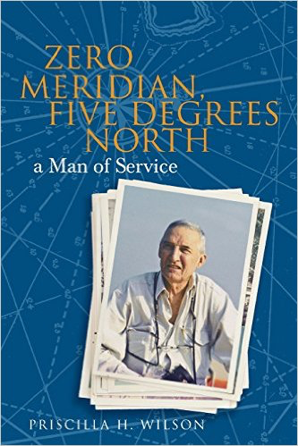

Rodney’s journey began several years before the Great Depression of the 1930s and ended with his work in global villages.  Never casual about his faith, his desire to be practically useful took many shapes during his eighty-five years.

Rodney Wilson often spoke of writing a book about his life. He left many notes, interviews, speeches, articles and the title he intended to use: *Zero Meridian, Five Degrees North*. He talked about having lived five lifetimes.

As his wife of fifty-nine years and now his widow, I decided to pull together this material and write his biography.

Memory is a funny thing. As we examine the events in our lives, a new level of meaning flows forth. Memory connects us to what has gone before, to that which really matters.

Only in looking back over our decades can we understand the hinge points that dramatically shaped our life.

The surprises that shaped Rodney’s life – and therefore mine included:

* A postcard invitation to join the youth choir.
* A war in Korea that blocked job opportunities and sent him to the Santa Fe Railway in Chicago “temporarily.”
* The word Ecumenical on a neighborhood center that our church sponsored.
* A group of women who decided their husbands should meet.
* A Rotary sign nailed to a tree in Chikale village in India.

www.TeamTechPress.com