**The Ferguson Ecology Team Video Night**

***Presents* *VIA* *ZOOM:***

***OYATE***

***The***[***Dakota Access Pipeline protests***](https://www.wikiwand.com/en/Dakota_Access_Pipeline_protests)***became an inflection point for Indigenous people and modern tribal sovereignty. Thousands of people from across the country gathered at the STANDING ROCK reservation to stand in solidarity with the Lakota people. Since then, community leaders have used their newfound platform to organize and educate people about their issues***.

**THURSDAY ~ FEBRUARY 22, 2024 ~ 7:00 PM**

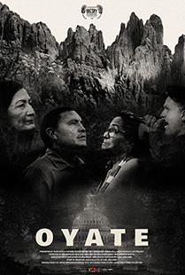

***OYATE uses the #NoDAPL struggle as a jumping off point to dive into an array of issues that affect Indigenous people. The film centers around a diverse group of Indigenous voices led by activist Phyllis Young, attorney Chase Iron Eyes, hip hop artist Stuart James, and***[***Secretary of the Interior***](https://www.wikiwand.com/en/United_States_Secretary_of_the_Interior)[***Deb Haaland***](https://www.wikiwand.com/en/Deb_Haaland)***as they unravel a history of systemic oppression defined by broken treaties, land theft, and cultural erasure. The latter half of the story follows the subjects on the ground as they take the fight to state governments, Washington DC, and eventually the United Nations.Top of Form***

|  |  |  |  |
| --- | --- | --- | --- |
| |  |  | | --- | --- | |  |  | |  |

***Bottom of Form***

**Conversation to follow the film**

**TO REGISTER FOR ZOOM LINK:**

**https://bit.ly/FETFeb2024**

**For more information: (314) 521-8418**

[**carletonstock@aol.com**](mailto:carletonstock@aol.com)