The Ferguson Ecology Team Video Night

Presents VIA ZOOM:

The Doctrine of Discovery
Unmasking The Domination Code

A story of historical truth, spirituality, and resistance,
told on behalf of the original nations and peoples of Great Turtle Island,
and elsewhere on Mother Earth. We are still here, and still rightfully free.

THURSDAY ~ JANUARY 25, 2024 ~ 7:00 PM

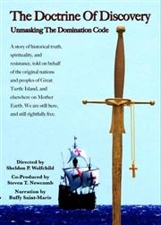

This film, based on Steven Newcomb’s book PAGANS in The Promised Land, explores the religious, political and legal systems that have, since the time of Christopher Columbus, been the foundation and precedent for dominating the peoples, lands and resources of original nations and other citizens in the United States and on other continents. The environmental impact and degradation from the ensuing political oppression, economic exploitation and religious legitimation of the Doctrine of Discovery continues to this day.
Conversation to follow the film
TO REGISTER FOR ZOOM LINK:
https://bit.ly/FETJan2024
For more information: (314) 521-8418
carletonstock@aol.com

