**The Ferguson ECOLOGY Team Video Night**

***Presents VIA ZOOM:***

***EXTINCTION***

**THE FACTS**

**With a million species at risk of extinction, Sir David Attenborough explores how this crisis of biodiversity has consequences for us all.**

**Thursday ~ February 16, 2023 ~ 7:00 PM**

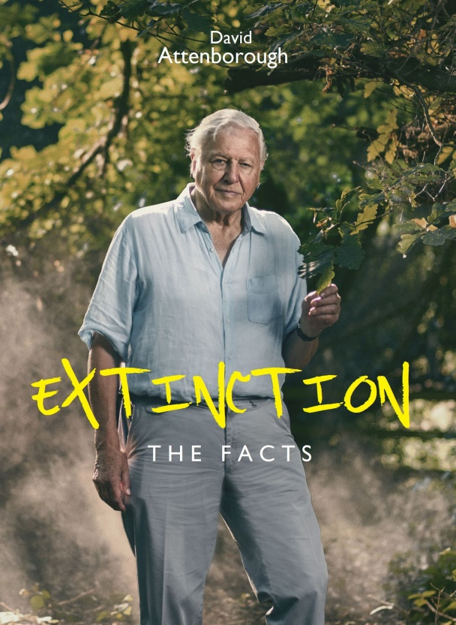

***EXTINCTION: The Facts*** is a 2020 documentary film by the natural historian [David Attenborough](https://en.wikipedia.org/wiki/David_Attenborough) which aired on the [BBC](https://en.wikipedia.org/wiki/BBC). Attenborough and academic experts comment on the [sixth mass extinction](https://en.wikipedia.org/wiki/Sixth_mass_extinction), caused by humans, and the consequences of [biodiversity loss](https://en.wikipedia.org/wiki/Biodiversity_loss) and [climate change](https://en.wikipedia.org/wiki/Climate_change). Humans are causing an animal and plant extinction rate roughly 100 times faster than has previously occurred. One million out of eight million species on the planet are at risk of extinction. It also suggests positive action which can be taken to halt or reverse these effects.

**Conversation to follow the film**

**TO REGISTER FOR ZOOM LINK:** [**https://bit.ly/FET16Feb2023**](https://bit.ly/FET16Feb2023)

**For more information: (314) 521-8418**

[**carletonstock@aol.com**](mailto:carletonstock@aol.com)