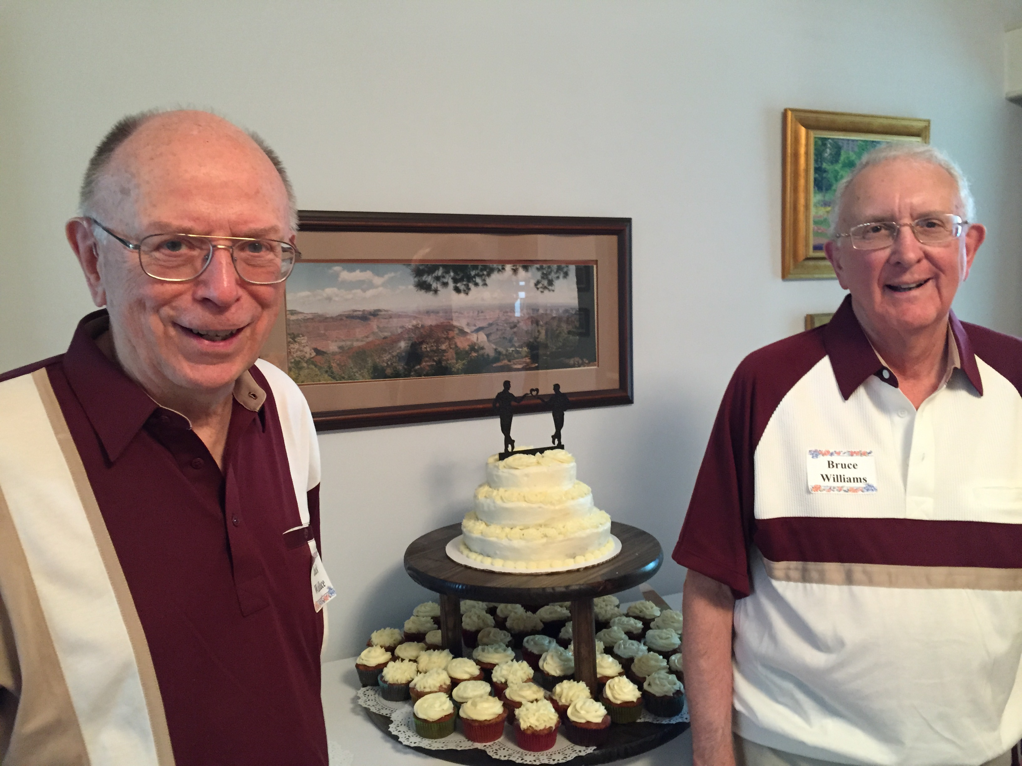

JOHN (JACK) CHESTER WALLACE
Husband of R. Bruce Williams
MAY 24, 1939 – FEBRUARY 27, 2021

Jack was born in Plainfield, New Jersey and spent a great of his life in Westfield, NJ. After graduating from high school in Westfield, from 1957-61, he attended Rutgers University in New Brunswick, NJ. There he studied Electrical Engineering. Bruce and Jack met in February, 1959. Jack continued on to graduate school in Northeastern University in Boston. MA, getting his Masters Degree in 1963. He was employed in the Bell System, working in Bell Labs, Western Electric, and New England Bell. He wrote programs in the mid-1980’s to enable the shift into digital software. After intermittent contacts and first marriages, Jack and Bruce reconnected in 1987. Upon turning 50, Jack took advantage of early retirement and moved to Chicago where Jack and Bruce lived until Jack’s death. Upon the Supreme Court decision in June of 2015, Jack and Bruce were married in August of 2015 (see above picture). Jack’s support made possible Bruce’s transition from 20 years with The Institute of Cultural Affairs to 6 years with Skylight Training and Publishing Company and then to an independent consulting role continuing to this day. As an elementary school student, he established a popular marionette show business. Later in life, he created a magnificent doll house as well as designed countless dioramas with model buildings. As a hobby, Jack successfully managed finances and investments using a computer program he modified. Jack and Bruce were able to do an amazing amount of traveling to National Parks as well as taking advantage of cruise expeditions as far away as Antarctica, Alaska, South Georgia Island, and Easter Island. He modeled generosity and loyalty throughout his life. He outlived his parents, John A. and Marjorie Egbert Wallace as well as two brothers, Richard and Bruce. He is survived by his husband, Bruce, his grandson, Saveen Williams, and his sister-in-law, Jill Wallace.

