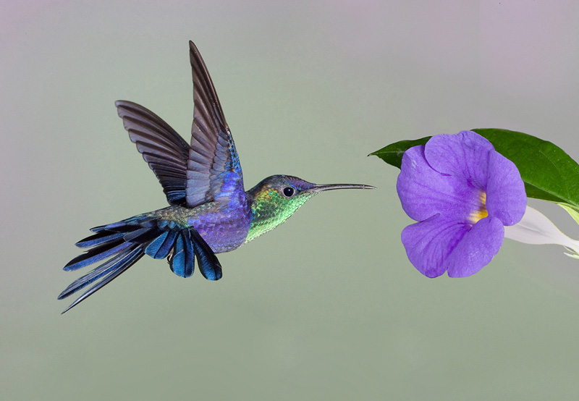

*What the Heart Cannot Forget*

*by Joyce Sutphen*

*Everything remembers something. The rock, its fiery bed,*

*cooling and fissuring into cracked pieces, the rub*

*of watery fingers along its edge.*

*The cloud remembers being elephant, camel, giraffe,*

*remembers being a veil over the face of the sun,*

*gathering itself together for the fall.*

*The turtle remembers the sea, sliding over and under*

*its belly, remembers legs like wings, escaping down*

*the sand under the beaks of savage birds.*

*The tree remembers the story of each ring, the years*

*of drought, the floods, the way things came*

*walking slowly towards it long ago.*

*And the skin remembers its scars, and the bone aches*

*where it was broken. The feet remember the dance,*

*and the arms remember lifting up the child.*

*The heart remembers everything it loved and gave away,*

*everything it lost and found again, and everyone*

*it loved, the heart cannot forget.*