A SONG BOOK
IN MEMORY OF JEAN LONG
MAY 20, 1940—APRIL 8, 2019
SPRING SOJOURN 2019
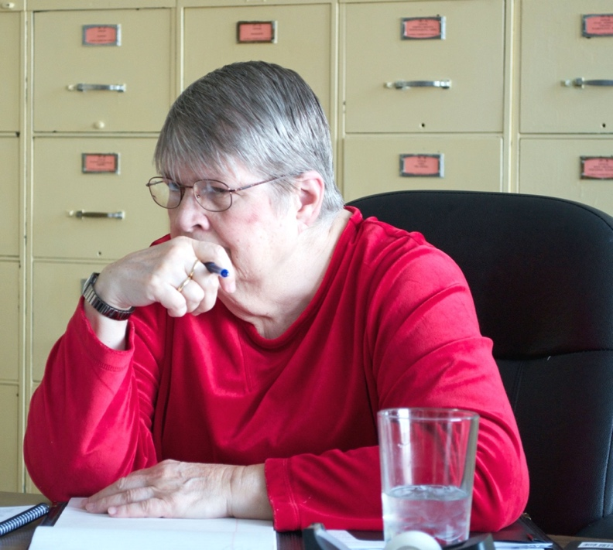

TABLE OF CONTENTS

AMAZING GRACE—9
BALM IN GILIAD—10
BE THOU MY VISION—11
BEAUTY—14
BEING—6
BELIEVE—8
BLUE SKIES—7
BYE BYE BLACKBIRD—4
CHICAGO IS A WONDERFUL PLACE—13
CHICAGO—9
COME AND GO WITH ME TO THAT LAND—10
HARVEST TIME—9
HEY GOOD LOOKIN’—5
I DON’T KNOW WHY—8
LOCAL MAN SHALL RISE AGAIN—13
LORD OF THE DANCE—12
OBEDIENCE—11
POVERTY—4
PSALM 13—7
RAGHUPATI RAGHAVA—7
SAINTS—5
THE EARTH BELONGS TO ALL—6
THE VISION—3
THOSE WHO WAIT ON THE LORD—10
WHEN I’M ON MY JOURNEY—4

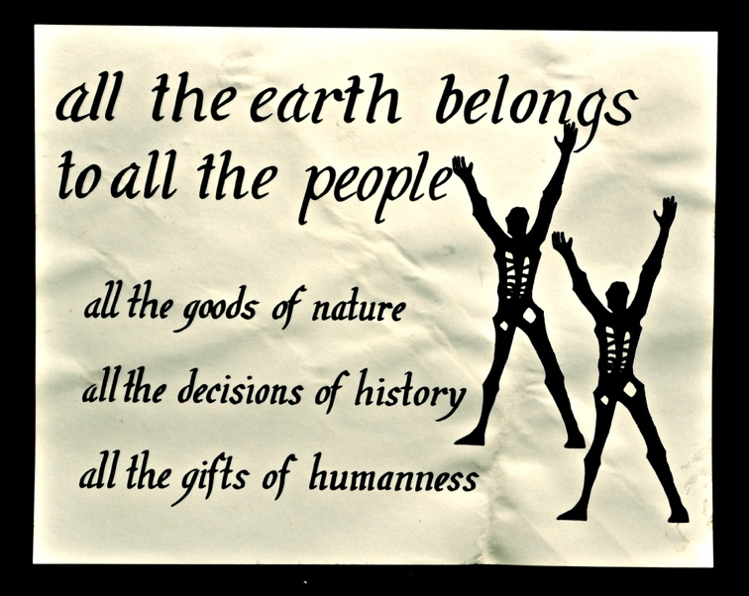

THE VISION
Contributed by Louise Ballard, Mary Laura Jones & Jann McGuire

We heard the cry from the past, we heard the cry set forth at last;
Our ancestors plead to live our time,
The crimson line their only awesome sign.
Now all the earth cries out within our hearts: agony.
Comes the dawn of silence.
Beyond the wanderings of time, beyond the race of all Mankind;
I see living bodies torn and crushed,
Life emerging from the arid dust.
Now the face I see is dark beyond all hope: mystery.
Comes the dawn of silence.
Pain and joy and hope unfold, pain and joy and hope untold;
We cannot contain ascending life, Nor escape the chaos and the strife.
Now the wonder of our God is struggle and love: eternally.
Comes the dawn of silence.
Lightning moment blazing spark, lightning moment in our dark;
The birth and death of every star and tree,
The dread assault of spirit within me.
Then God confronts me with terror and with love: ecstasy.
Comes the dawn of silence.
Burning flame and life is born, burning flame and all is gone;
Trembling and afraid above the abyss,
Grasping now that only nothing exists.
Then I plumb the abyss, my life becomes new birth, ceaselessly.
Comes the dawn of silence.

WHEN I’M ON MY JOURNEY
Contributed by Isobel Bishop

When I'm on my journey
There is no one there but me.
When I'm on my journey
There is no one there but me.
When I'm on my journey
There is no one there but me.
Lord, I know There is no one there but me.

. . . I am one with family.
. . . Spirit colleagues there will be.
. . . All mankind I will see.
. . . We will bend all history
. . . There is no one there but me.

BYE BYE BLACKBIRD
Contributed by Randy Williams

Pack up all my care and woe
Here I go singing low
Bye Bye Blackbird.
Where somebody waits for me
Sugar's sweet so is she
Bye bye blackbird. ¬

No one here can love and understand me
Oh what hard luck stories they all hand me
Make my bed and light the light.
I'll arrive late tonight
Blackbird, Bye bye.

POVERTY
Contributed by Linda Cock

Come walk with Francis Bound too by fame? Then Drawn too by surety? Belong in the tension
Like him you'll You must leap Living is to Where life and
Naked die O'er that shoal Be unsure Death contend

Free all you now cherish Your calling's been written So pour your life wholly As bridge to the future
For time soon will Upon the Each burden you Burn out the flesh
Pass you by Ages scroll Will endure Time did lend

If you would do something The mass of most men Abound with Paul and If holiness binds you
Then be God's nothing Laugh and don't listen Run the race and Leave it behind you
Be the Lord's Say that you've In fullness Such vestments
Fool and fife Failed, gone mad There abase You must rend

In holding to naught Yet when all seems wrong In all that you do The only defence
There the secret is found You wink and appear gone Make this your song In the battle that's won
You are wealth Lo, the Lord's That all earth Is life-in-depth,
When not by wealth New face is To all men The Kingdom

SAINTS
Contributed by Frank Knutson

Oh, when the Saints go marching in
Oh, When the Saints go marching in
Lord I want to be in that number
When the Saints go marching in.

2. And when the Revelation comes
3 Oh, when they gather around he Throne
4. And when the crown Him King of Kings
5. And when the Sun no more will Shine
6. And when the Moon has turned to Blood
7. And when the Earth has turned to Fire
8. Oh, when the Saints go marching in.

HEY GOOD LOOKIN’
Contributed by Paula Philbrook

Hey, hey, good lookin',
Whatcha got cookin'?
How's about cookin' somethin' up with me?
Hey, sweet baby,
Don't you think maybe
We could find us a brand new recipe?
I got a hot-rod Ford and a two-dollar bill
And I know a spot right over the hill.
There's soda pop and the dancin's free,
So if you wanna have fun come along with me.
Hey, good lookin',
Whatcha got cookin'?
How's about cookin' somethin' up with me?
I'm free and ready,
So we can go steady.
How's about savin' all your time for me?
No more lookin',
I know I've been tooken.
How's about keepin' steady company?
I'm gonna throw my date-book over the fence
And find me one for five or ten cents.
I'll keep it 'til it's covered with age
'Cause I'm writin' your name down on every page.
Hey, good lookin',
Whatcha got cookin'?
How's about cookin' somethin' up with me?

BEING
Contributed by Beret Griffith

My life is as I see them as Then I act seeing Then the Lord through
Vast as the sea Never before Action is vain My life prays a prayer
No boundaries The secrets of And accomplishments And my being as
Floor beneath me Heaven my store Never as gain Filled being there

Yet as I look within With wisdom twice my age To only do is less I can invent anew what
No man has greater sin My life an open page Than forming humanness So All the saints once knew
I am the least of all Through with each insight Mission I must be By being who I am
I daily fall Gain a deeper pain To set men free I create man

But it’s then when I Yet I live with the Called to burn as an Undying And it’s no longer
Doubt that I can Lord on my side Flame I who is seen
I choose to be nothing And wild intuition Each word and each But the Lord standing
For man My guide Gesture the Name There in between

To die is my lot I’m sent as a sign I must through life-loss Finished as I die
I live as if not The bread and the wine An exalted cross Held there between
With Paul My form My place Sky and sod
I merge with all And virgin born Reveal his face To serve our God

Yes, it’s there on the limbs of the worm-eaten tree where the All and the nothing can BE.

THE EARTH BELONGS TO ALL
Contributed by Jo Nelson

The flowers of the meadow are greeting the sun
The trees in the forest stand tall.
But gather together to march as one.
The earth belongs to all.

Chorus.
All of the goods of the earth and all
Decisions of history,
And all the inventions of humanness
Belong to all men through me.

The branch of the linden is leafy and green
The maples are golden in fall.
But somewhere a glory awaits unseen.
The earth belongs to all.

The cries of the innocent sound in their pain,
The tyrant has vanquished the small.
A powerful ruler lies bound in chains,
Till earth belongs to all.

A dream of the future is beckoning me.
Like waltz music heard at a ball.
The morning will come when all men shall see.
The earth belongs to all.

Oh Father, Oh Father, Mysterious Power,
Your children are gathered to call.
Use us as thy servants to haste the hour
The earth belongs to all.

BLUE SKIES
Contributed by Susan Carver

Blue skies smiling at me, nothing but blue skies do I see
Blue birds singing a song. nothing but blue birds all day long.
Never saw the sun shining so bright,
Never saw things going so right.
Noticing the days hurrying by.
When you're in love,
My! how they fly.
Blue days, all of them gone.
Nothing but blue skies from now on.

PSALM 13
Contributed by Linda Cock

How long, O Lord, wilt thou quite forget me?
How long wilt thou hide thy face from me?
How long must I suffer anguish in my soul,
Grief in my heart, day and night?
How long shall my enemy lord it over me?
Look now and answer me, O Lord my God.
Give light to my eyes lest I sleep the sleep of death,
Lest my adversary say, I have overthrown him,
And my enemies rejoice at my downfall.
But for my part I trust in thy true love.
My heart shall rejoice, for thou hast set me free.
I will sing to the Lord, who has granted all my desire

RAGHUPATI RAGHAVA
Contributed by Nelson Stover

Refrain.
Raghupati Raghava Rajaram,
Patita pavana Seetaram. (Repeat couplet)

Seetaram. Seetaram.
Sabhuko Sanmati de Bhagawan. (Repeat couplet)

Raghupati Raghava Rajaram,
Patita pavane Seetaram. (Repeat couplet)

Ishwar' Allah tere nuam,
Sabhuko sanmati de Bhagawan. (Repeat verse)

I DON’T KNOW WHY
Contributed by Louise Ballard

I don't know why I love you like I do,
I don't know why, I just do.
I don’t know why you thrill me like you do,
I don't know why, you just do.
You never seem to want my romancing,
The only time you hold me is when we're dancing,
I don’t know why I love you like I do,
I don't know why, I just do

BELIEVE
Contributed by Beret Griffith

Chorus:
Believe that the time has come.
This world's going to live as one
And people are ready now
To create a new way.
New Spirit alive
New dream on the r~se
One world together
Create the new day.

Everybody can see
A new way that it can be,
But so many things just seem to get in the way.

The chains that bind us are strong.
The road to liberty long
Toward one world together
New earth, a new day.
Listen and you will hear
The future is coming clear
And everybody alive
has something to say.
We share a bit of the load,
Walking down the same road,
Working together,
New earth, a new day.

HARVEST TIME
Contributed by Frank Knutson

The seed I have scattered in springtime with weeping, and watered with tears and with dews from on high:
Another may shout when the harvesters reaping, shall gather my grain in the sweet by and by.

Refrain:
Over and over, yes, deeper and deeper, my heart is pierced through with life's sorrowing cry.
But the tears of the sower and the songs of the reaper shall mingle together in joy by and by.
By and by, by and by, by and by. by and by.
Yes the tears of the sower and the songs of the reaper shall mingle together in joy by and by.

Another may reap what in springtime I've planted. Another rejoice in the fruit of my pain.
Not knowing mv tears when in summer I fainted while toiling sad hearted in sunshine and rain.

Thorns will have choked and the summer sun blasted the most of the seed which in springtime l've sown.
But the Lord who has watched while m! weary toil lasted will give me a harvest for what I have done.

Coda:
Then palms of victory, crowns of glory, palms of victory. I shall wear.

AMAZING GRACE
Contributed by Frank Knutson

Amazing grace how sweet the sound that saved a wretch like me
I once was lost, but now am found was blind. but now I see.
'Twas grace that taught my heart to fear and grace my fears relieved.
How precious did that grace appear. the hour I first believed.

Through many dangers' toils and snares I have already come.
'Tis grace that brought me safe thus far. and grace will lead me home.

When we've been there ten thousand years bright shining as the sun.
We've no less days to sing God's praise then when we'd first begun.

CHICAGO
Contributed by Frank Knutson

Chicago, Chicago, that toddling town.
Chicago, Chicago, I'll show you around.
Bet your bottom dollar you'll lose your blues,
In Chicago,
The town that Billy Sunday could not shut down.

On State Street, that great street I just want to say
They do things they don't do on Broadway –
You'll have the time, the time of your life.
I saw a man, he danced with his wife,
In Chicago, Chicago, my hometown.

THOSE WHO WAIT ON THE LORD
Contributed by Seth Longacre, David and Margaret Scott & Dawn Collins

Those who wait on the Lord
Shall renew their strength.
They shall mount up on wings as eagles.
They shall run and not be weary,
They shall walk and not faint,
Help us, Lord, help us, Lord, in Thy way.

Those who love the Mystery . . .
Those who live the risen life . . .
Those who serve the suffering world . . .
Those who die on the march .

BALM IN GILEAD
Contributed by Dawn Collins

Refrain
There is a balm in Gilead
To make the wounded whole.
There is a balm in Gilead
To heal the sin sick soul.

Sometimes I feel discouraged
And think my work in vain,
But then the Holy Spirit
Revives my soul again.

If you cannot sing like angels,
If you cannot preach like Paul,
You can tell of the love of Jesus
And say he died for all.

COME AND GO WITH ME TO THAT LAND
Contributed by Frank Knutson
Come and go with me to that land, come and go with me to that land
Come and go with me to that land where I'm bound, where I'm bound.
Come and go with me to that land, come and go with me to that land,
Come and go with me to that land where I'm bound.
There is mystery in that land....
There is freedom in that land....
There is caring in that land....
There is glory in that land....
Come and go with me to that land....

BE THOU MY VISION
Contributed by Dawn Collins

Be thou my Vision. O Lord of my heart;
Naught be all else to me, save that thou art;
Thou my best thought by day or by night,
Waking or sleeping, thy presence my light.

Be thou my Wisdom, and thou my true Word;
I ever with thee and thou with me, Lord;
Thou my great Father, and I thy true son,
Thou in me dwelling, and I with thee one.

Riches I heed not, nor man's empty praise;
Thou mine inheritance, now and always.
Thou and thou only first in my heart,
High King of heaven, my treasure thou art.

High King of heaven, my victory won'
May I reach heaven's joys, O bright heaven's Sun!
Heart of my own heart, whatever befall
Still be my Vision, O Ruler of all.

OBEDIENCE
Contributed by Dawn Collins

Come all spirits Let the light that Heed the cries that Live your life
Roaming freely Fights with darkness Sound your passion Before the calling
Bind your will in Show your rights and Bleed with every To discern the
Common thrust Everyman’s Struggling one Will of God

Stand beneath the Place your share Will that you might Each man of the
Gaze of neighbor upon the alter Live to free them Globe your brother
Ready to obey Burn it at the Speak the Word, the Each demand a
Their trust Lord’s command Deed be done Weight and rod

Take within yourself Speak with lightening Launch with those who Choose to follow
The burden When the shadows Share the vision On the ascending
Peace on earth, Blind the eyes of To expand man’s Know that alone to
Good will to men Those you love Destiny Be on your way

All the world is Never let the In the life that’s Then join hands
Now your parish Clouds of winning Born of drowning Beyond the border
Every spirit Block the glorious Sail with friends who With the Saints in
Yours to win Sun above. Wage the sea Bright array

LORD OF THE DANCE
Contributed by Frank Knutson

I danced in the morning when the world was young
I danced in the moon and the stars and the sun
I came down from heaven and I danced on the earth
At Bethlehem I had my birth

Dance, dance, wherever you may be
I am the lord of the dance, said he
And I lead you all, wherever you may be
And I lead you all in the dance, said he

I danced for the scribes and the Pharisees
They wouldn't dance, they wouldn't follow me
I danced for the fishermen James and John
They came with me so the dance went on

Dance, dance, wherever you may be
I am the lord of the dance, said he
And I lead you all, wherever you may be
And I lead you all in the dance, said he

I danced on the Sabbath and I cured the lame
The holy people said it was a shame
They ripped, they stripped, they hung me high
Left me there on the cross to die

Dance, dance, wherever you may be
I am the lord of the dance, said he
And I lead you all, wherever you may be
And I lead you all in the dance, said he

I danced on a Friday when the world turned black
It's hard to dance with the devil on your back
They buried my body, they thought I was gone
But I am the dance, and the dance goes on

Dance, dance, wherever you may be
I am the lord of the dance, said he
And I lead you all, wherever you may be
And I lead you all in the dance, said he

They cut me down and I leapt up high
I am the life that will never, never die
I'll live in you if you'll live in me
I am the Lord of the dance, said he

Dance, dance, wherever you may be
I am the lord of the dance, said he
And I lead you all, wherever you may be
And I lead you all in the dance, said he.

LOCAL MAN SHALL RISE AGAIN
Contributed by Jo Nelson

Born in plenty, raised up blind.
All turned hollow, something there was wrong.
Human suffering over all the world—
Three people die and never live.

Refrain:
All the earth belongs t o all.
That’s the vision and the call
Local Man shall rise again
To build the earth, the common earth.

Joined the rebels, lost the past.
Saw destruction, nothing really changed.
Human suffering over all the world—
Three people die and never live.

Then a stranger, loved by none.
All was gone, every hope had died.
Human suffering over all the world—
Three people die and never live.

At the center,aweful calm.
Born of spirit, then my life was gone.
Human suffering over all the world—
Three people die and never live.

From the center, we shall stand.
In every nation, throughout every land
Building patterns to release the new:
Dying daily that the new may live.

CHICAGO IS A WONDERFUL PLACE
Contributed by Dawn Collins

Chicago is a wonderful place,
The West Side's where we live;
Chicago is a wonderful place,
The West Side's where we live.

So sing all you people, life is here to love;
So sing all you people, life is here to live.

Chicago is a wonderful place,
The West Side's where we live;
Chicago is a wonderful place,
The West Side's where we live. (3 times)

BEAUTY (A Refrain)
Contributed by Nancy Lanphear

Beauty all above you, beauty all below you,
Beauty all around you, beauty all within you

All above you, all below you,
all around you, all within you

You are beauty, you are beauty

You see the beauty of the dancer
You hear the beauty of the song
You feel the beauty all around you
You wonder where do you belong.
You are the beauty of the dancer
You are the beauty of the song
You are the beauty all around you
You're standing right where you belong.

