C:\Users\PRT\AppData\Local\Microsoft\Windows\Temporary Internet Files\Content.IE5\2753D9E9\MC900440074[1].wmf***May the warmth and love that surrounds us at Christmas time***

***fill your heart with joy, and shed radiance over the year that lies ahead.***

2013 has been a good year for us.

In brief: Dan’s health has stabilized; Pat has retired from her facilitation business,

& we’ve moved to Portland, Oregon!

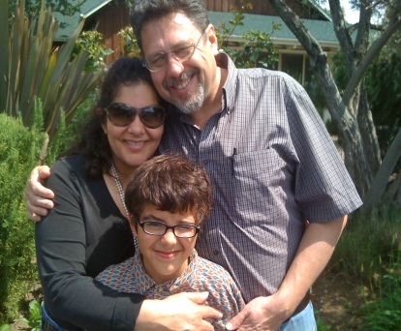Dan’s improved health and Pat’s retirement gave us the opportunity in the last 6 months to take several short, enjoyable trips – our first in two and a half years.

We took a mini vacation to Napa Valley and were joined by our son, Rick Jones and his partner, Sue Mueller, and their 10 year old son, Teddy from the Bay Area. What a delightful time it was. Sue used to work at a winery in CA and she kept us informed about the wineries we visited and wines we tasted.

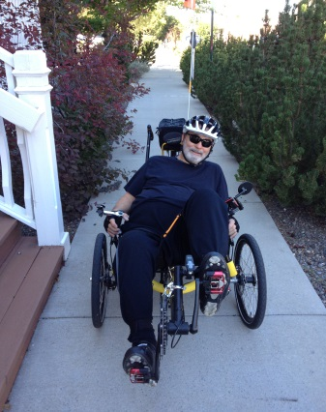

One weekend we went to Tahoe City in the Sierra Nevada. There the Truckee River flows from Lake Tahoe, on its way to Truckee CA, Reno, NV and empties into Pyramid Lake, NV. A slow moving section near Tahoe City is very popular for tubing parties and bicycling along the level bike path that parallels the river at that point. We took Dan’s recumbent Trike and he had a great time riding along the river. It was the first time in months that he was able to ride it.

In July we went to Seattle to celebrate Lee & Leah Early’s 50th wedding anniversary. We were a surprise part of the evening along with Leah’s sisters who flew in from Texas and two women from Leah’s Wise Women’s Group, Dorothea Jewell and Joan Knutson. The event was a memorable dinner at an marvelous restaurant. Diane, Laura and Rebecca Early planned, coordinated logistics and hosted the celebration for their parents and managed to keep part of it a surprise. The stories that got told that evening were funny, dear, and awesome.

Some of you know that in 2010 - 2012, Dan had multiple trips to the ER and hospital admissions for blood clots in his legs, pulmonary embolism, cellulitis infections, and several surgeries. He was in the hospital one time for 90 days with back surgery, skilled nursing, and rehab. After only two days home he was back to the hospital again for another surgery. Those years were awesome, filled with challenges galore. The good news is that 2013 has been very different. In Jan–April of this year, Dan had only 4 trips to the Emergency Room and only 3 brief hospital admissions. Doctors changed his blood thinner medication and, so far, it has worked beautifully. Pain and energy management and strength building are the focus now. He turned 70 in October.

I have retired from my facilitation business and am not sure where my creative energy will take me next. I took a Reiki Level One training that I’ve wanted to do for some time. A current challenge is disposing of 30 years of professional files. An unexpected gallbladder surgery on Mother’s Day was my hospital experience – as a patient, that is. I just relaxed, caught up on sleep and reading, and let others do the care taking for a change.

Another trip was a visit to Portland and our son Eric, his wife Tina, and two granddaughters, Katy, 11, and Grace, 7. We had decided a couple of years ago to move to Portland to be closer to family so Dan could experience “being a grandfather before he forgets he is one”. Health issues delayed that move.

This time when we returned to Reno, we were in a whirl wind of packing. With our fingers crossed we rented an apartment online! Our west coast sons, Rick Jones and Eric Tuecke, came to help move us and, believe me, they were great. They had not spent any time together since Eric and Tina’s wedding way over a decade ago. It was wonderful to see them take charge of the packing, loading, and driving the truck to Portland and then unloading and moving us in. We all held our breath walking into the apartment and let out a collective sigh of relief - it was a great place. We love it. With lots of help from strangers, friends, and our sons, to whom we are extremely grateful,we actually hit our target date and drove to Portland on our 34th wedding anniversary, September 15.

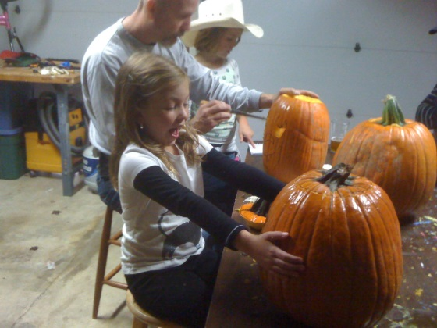Since then our time has been divided between settling in, learning our way around in a bigger city, finding doctors and being ‘hands on’ grandparents. We had wonderful times with them on Halloween, Thanksgiving, school concerts and baby-sitting. We look forward to Christmas morning with them.

We fly to the Bay Area Christmas afternoon to celebrate with Rick, Sue and Teddy. The next day, Dec. 26, we will celebrate Rick’s 50th birthday!

Through the phone we stay connected to our family in Iowa, Dan’s 95 year old mother, Ruth, and our son Troy in Dubuque. He has a new job their selling Geico insurance. He’s inherited Dan’s sales ability. In only two weeks he had the second best closing ratio in the office.

We appreciate the caring prayers and healing thoughts sent our way over the past few years. We are so blessed to be part of this circle of family, friends and colleagues.

Our contact info:

Our new address is: 15191 SW Royalty Pkwy, Apt. K17, Tigard, OR 97224

Dan: [tuecke@gmail.com](mailto:tuecke@gmail.com) 775-527-4515 mobile

Pat: [ptuecke@gmail.com](mailto:ptuecke@gmail.com) 775-813-3871 mobile

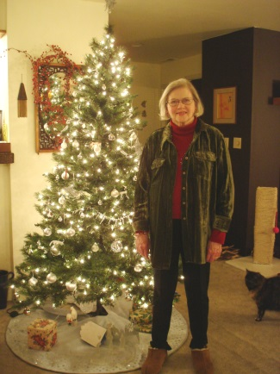

Merry Christmas

C:\Users\PRT\AppData\Local\Microsoft\Windows\Temporary Internet Files\Content.IE5\2753D9E9\MC900440074[1].wmfPat and Dan