***Transformative Leadership for***

***Sustainable Human Development***

Robertson Work

Adjunct Professor, New York University Wagner Graduate School of Public Service

Founder/Director, Innovative Leadership Services

(Former UNDP Principal Policy Advisor, Decentralized Governance

and former Director of ICA in Korea, Jamaica and Venezuela)

**Introduction**

The aim of this chapter is to provide a reflection on the critical times in which we live and future scenarios of development, governance and leadership. First a brief reflection is offered on social philosophy and the social contract raising a few important questions. Next the chapter provides an analysis of the critical decade of crisis and opportunity in which we find ourselves, the new civilization that is emerging and the importance of working at the community level. Following this, there is a discussion of the role of transformational leadership in 21st century public service. Finally, the chapter provides a few thoughts on the integration of four key themes and possible actions.

I. **Social Philosophy**

What is a *human* being? What is development? What then is human development? What is the purpose of societal organization and governance in relation to human development?

These are not only philosophical questions but urgent, practical questions. These are some of the profound questions facing us as a species. Our responses to these questions, both in our individual thought and behaviour and in our collective culture and systems, will determine how human society and life itself flourishes or declines on planet Earth. If this is so, how is it so?

There are many views of what constitutes a human being. Is a human being a spiritual being of infinite worth? Or primarily a consumer of goods and services? Or a resource for economic production? Or primarily a citizen of the State? Or simply another mammal? Or a child of God? Is a human being basically good? Or fundamentally evil? Does each human being who is born have universal rights guaranteed by society? What are the rights of future generations? What is the full potential of each human being? What is the ultimate purpose of human beings on planet Earth or in the universe as a whole? Our answers to these questions spring from our own acculturation and socialization as provided by our culture, religion, political ideology, personal reflection, age, sex, and so forth. Some people believe that only their group is truly human and that all others lack truth and legitimacy.

The dominant answer in the world today to the question of what constitutes development is material and economic progress, industrialization and modernization. The race is on to increase GDP per capital and fuel a consumption-production society at any cost to nature and people. However, this purely economic definition is doing much harm to natural systems and human culture.

Each definition of humanness carries with it an implicit or explicit definition of development. If a human being is primarily a spiritual being, then society would be designed in a way that would help each person realize his/her spiritual potential. If a human being is primarily a consumer, then he/she is to be manipulated by advertisements to purchase certain goods and services. If a human being is primarily a citizen of a democratic state, then she/he is empowered to express her/his opinions through voting and is responsible to act in accord with the laws of the State. If a human being is understood simply as another mammal, then she/he will be treated that way. If a human being is understood to be a child of God, then she/he will be cherished as a holy being.

If a human being is understood to be basically good, then society structures itself in order to nurture this quality and will design systems based on trust of this basic goodness. If a human being is understood as fundamentally evil, then society will design systems that seek to control and punish these dark impulses. If every human being who is born has universal human rights, then society will design systems to ensure adequate opportunities and access to quality education, healthcare, housing, credit and self-expression of each and every person. If future generations have the same rights as the present generation, then society will ensure that the resources of the Earth are preserved and developed with this in mind. If every human being has the right to realize his/her full potential in this life, then society will be designed to ensure that this can happen. If human beings believe that they have an ultimate purpose on planet Earth and in the universe as a whole, then this will provoke profound dialogue in society and help direct the design of social systems toward a learning society.

What then is “human development”? As we have seen, different definitions will flow from different views of the human being. In the view of the United Nations and the international community at large, the human being is guaranteed universal rights by society as articulated in the Declaration of Human Rights. The UN has been analyzing and promoting “human development” or “sustainable human development” over the past twenty years. Furthermore, the Millennium Development Goals were agreed upon to provide tangible targets for human development over the short term.

How then do nations and local communities understand the *social compact* that guides the design of social systems for the benefit of all human beings, all living beings and the finite resources of planet Earth including plants, animals, water, soil and air? Based on the Universal Declaration of Human Rights, the social compact directs that human beings agree to care for each other to ensure that each person has the necessary conditions for a full and meaningful life while ensuring that future generations have the same right.

This means that in order for all people to enjoy these rights, no group of individuals should be allowed to make this impossible by the over accumulation of economic wealth, political power or cultural dominance.

With this reflection as a backdrop, what are the current challenges facing humanity and indeed all life on Earth?

II. **The Critical Decade: Crisis and Opportunity**

Many social analysts, the author included, believe that we have just entered **the most critical decade** in human history – a time to do what is needful or face the direst of consequences. Other generations thought they were it; they were wrong; this is it. If we do the right things, the future of life on Earth can be brighter than we can imagine. If we don’t, the future could be dismal and even disastrous.

We are in the midst of a whole systems transformation – a time of chaos, crisis and possibility. We are facing multiple, interlocking crises including climate chaos, economic injustice, increasing poverty, dysfunctional governance, unsustainable energy, gender inequality and an HIV/AIDS pandemic. Each of these crises, however, is also an unparalleled opportunity for reinvention of the human enterprise.

We as a global society have the tools and technology needed to solve each of these crises; what we lack is collective agreement and action. We must, at the same time, transform individual consciousness and behavior and collective culture and systems.

These crises are an opportunity to reinvent nothing less than human society itself from the bottom up, the top down and the inside out based on principles of *sustainability, equity, justice and participation*. We can literally create a world that works for everyone – societies that enable each person to realize her or his full potential.

There are a number of interlocking crises which represent incredible opportunities:

Environmental

The natural systems of Earth that have supported human civilization for the past 12,000 years are changing drastically and human societies must adjust quickly or adapt to a diminished Earth over the long term. Global climate change is real. The Greenland ice cap is melting. Antarctica which has 90 percent of the earth’s ice is melting. Mountain glaciers in the Andes and Himalayas and the Siberian permafrost are melting. Deforestation is accelerating. Carbon dioxide and methane gases are rapidly heating up the planet. We are already past 350 parts per million (ppm) of carbon dioxide in the atmosphere – the highest concentration without dangerously heating up the Earth. This means that if this heating up goes unabated, the seas will rise up to six feet and flood coastal cities and cover up islands. In other parts of the world there will be massive desertification, droughts and food collapse. Mega storms will be the norm. There is already a massive die-back of species. There will be social, political and economic crises with mass migration and resource wars. Drinking water will become very scarce and wars will be fought over this life-essential resource. The next ten years will tell the story of our future – misery or happiness.

The opportunity before us is to let go of carbon-based energy, “death-energy” from dead animals and plants, and to invent a sustainable development path for humanity and all life forms. We can and must shift to renewable energy, “life-energy”, from the sun, water, wind, geo-thermal, algae and bio-fuels. But we must do this swiftly to avert disaster.

Economic

The global economic crisis we are in the midst of is a result of a financial system that is divorced from nature and social justice. Corporations, treated as persons and driven solely by profit motive, are endangering natural ecosystems and subverting democratic institutions. The opportunity here is to invent a new financial order, to reinvent money, and reinvest value in nature and people. And we must end the madness of the consumption-production cycle and create the Learning Society.

Political

We are in the midst of governance collapse. It is a crisis of democracies which have become plutocracies controlled by banks and insurance companies, the oil and coal industry, other corporations and the super-rich. The opportunity lies in reinventing governance that is participatory, just and in line with sustainable development goals.

Social

The major crises are in healthcare and education. We have an opportunity to catalyze a new commonsense of the universal rights to education and healthcare.

Cultural

We face a crisis of the sunset effect of fear-based fundamentalisms – Christian and Hindu as well as Muslim. Yet through this, the opportunity exists for a shift to an evolutionary Earth story, empathic consciousness and the rise of the Cultural Creatives (Paul Ray).

There is a pathway forward. We need to put an end to our purely production-consumption society, end the unrealistic concept of unlimited growth and drive towards a sustainable, equitable, participatory, just society. We need renewable energy, an equitable financial system, participatory governance, environmental protection, universal healthcare, education for all and gender equality. We need new ways of thinking, new assumptions, and new myths, policies and collective action. Awakenment must proceed and accompany action and commitment. We need to understand how to stay awake and how to act mindfully. We need a “lure of becoming” that draws us out of the present delusion and morass toward a hoped-for future.

Within this very moment of crisis, a **new civilization** is emerging. It is an Earth-based civilization of sustainable human development. In this new civilization, people will increasingly embody a consciousness of being part of the living Earth, of being part of the life force of our beautiful planet. We are all Earthlings. All people and all life forms are our brothers and sisters. We have a common future or no future at all. In the new civilization, people will embody behavior that is empathic and compassionate. People will embody a culture of peace, creativity and learning. People will embody systems, policies and institutions of equality, justice and universal participation in decision-making. And if we do not create such a civilization, the alternative will be chaos, tyranny, suffering and systems collapse.

In the midst of this critical decade we must build a new civilization of sustainable human development country by country, organization by organization, and most importantly, community by community.

The author’s first experiences in community development were on the West Side of Chicago working with the Institute of Cultural Affairs, an NGO in the African American ghetto in the 1960s. The NGO was catalyzing a demonstration of how any community in the world could transform itself economically, socially, culturally and politically. The pilot project was named 5th City. As people from outside the community, the NGO’s role was to empower, train, equip and connect the local residents to do their own development.

We worked within a geographically delimited area and involved all the people, all age groups and addressed all issues simultaneously which we called integrated human development. We found through hard experience that symbols were the keys to community renewal. 5th City created songs, stories and symbols that inspired local residents to transform their community. There was a sculpture of the Iron Human on 5th Avenue, songs of empowerment in the preschool and in community meetings and stories of heroes doing the impossible and creating a new world. Residents understood that what they were doing was on behalf of the whole world. 5th City was a global human development demonstration project and this was perhaps the most powerful motivation of all.

And we learned that every community has a depth contradiction that is blocking its development that must be addressed. For 5th City it was the victim image – people felt that they were powerless to create their own destiny. One way to counter this was to create empowering songs for the preschool children such as this one: “I am always falling down. But I know what I can do. I can pick myself up and say to myself. I’m the greatest too. It doesn’t matter if you’re big or small. You live now if you live at all. I am always falling down. But I know what I can do.”

Based on the 5th City model we created a participatory planning methodology that any community could use. We took it around the world and launched human development projects in the 24 time zones of the planet. The author helped launch two projects in the Republic of Korea, one on Cheju Island in the village of Kwang Yung Il Ri and one near the DMZ, Kuh Du I Ri. He also worked in village projects in Jamaica (Woburn Lawn) and Venezuela (Cano Negro). Eventually our NGO was working in hundreds of communities around the world including mass replication in India and Kenya.

When the author joined UNDP in 1990, he helped design and launch a global program to renew urban slums and squatter settlements around the world. The LIFE program (the Local Initiative Facility for the Urban Environment) worked in 12 pilot countries around the world in 300 cities. Local residents worked in collaboration with local authorities and NGOs in improving their living environment. We called this “local-local dialogue.” Through small grants for micro projects local people improved their solid waste management, potable water, environmental health and education and drainage, gender equality and created local jobs.

At the beginning of this century the nations of the world launched through the UN the Millennium Development Goals (MDGs) initiative. This was the first time in history that the world had agreed on tangible, time bound goals to improve the lives of people all around the world. These goals included eradicating poverty, empowering women, providing early education, protecting the environment and mitigating HIV/AIDS and malaria. Many of us in the UN believed that the key to achieving these goals was in their localization. Therefore, we launched initiatives to localize the MDGs in urban and rural communities around the world, such as Decentralizing the MDGs through Innovative Leadership.

And now, those who care about the future of life on Earth are intending to create a new civilization country by country, community by community, lesson by lesson, story by story. This is our noble cause.

III. **21st Century Public Service and Transformative Leadership for Sustainable Human Development**

Public service in the 21st century faces many challenges and opportunities. In the midst of the breaking down of an old civilization and the emergence of a new civilization, public service is now called more than ever before to provide innovative leadership for sustainable human development.

There are many styles of leadership which follow a developmental progression (Dennis Emberling). First leadership can be authoritarian, exploitative and coercive. Here the leader is the boss, dictator or employer. Next leadership can be bureaucratic with the focus on rules and roles, Here the leader is a manager, administrator or “parent.” The third stage of leadership is pragmatic with a focus on results. Here the leader is a guide. Next, leadership can be based on values and principles. Here the leader is a facilitator, coordinator or coach. And finally, leadership can be systems-based with a concern for multiple perspectives. Here there are no managers but true delegation of responsibility to all members of the team.

What then are the most effective means in this critical decade with which to build a new civilization country by country, community by community, organization by organization? **Transformative** **leadership** approaches are an essential key to unlock the potential of countries, communities and organizations. From four decades of international development work the author is aware of many leadership methods and approaches which have been applied within UN programmes, national governments, NGOs, private companies, local communities and universities. A few of the many effective ways of building creative countries, organizations and communities through innovative leadership follow.

Change requires new systems, policies and institutions but these alone are not enough. In order to create effective change, we must also transform individual consciousness and behavior and collective culture. These four dimensions of leadership based on Ken Wilber’s quadrants of integral development are all essential: change that is both individual and collective and internal and external.

|  |  |  |
| --- | --- | --- |
| **Four Quadrant Integral Framework** | | |
|  | **Interior** | **Exterior** |
| **Individual** | * Consciousness * Mindset * Awareness * Values * Attitudes | * Behaviour * Interpersonal * Relational * Partnerships * Group Skills |
| **Collective** | * Culture * Myths/Stories * Rituals/Rites * Symbols * Norms | * Environment * Organizations * Institutions * Systems * Policies |

The individual/interior dimension of integral leadership includes the consciousness, mindset, awareness, values and attitudes of the leader and his/her development of these in other individuals. The individual/exterior dimension includes the individual behaviour of the leader, interpersonal relations, partnerships and group skills and her/his development of these with other individuals. The collective/interior dimension of leadership includes the leader’s work with and transformation of cultural beliefs and values, myths and stories, rituals and rites, symbols and norms for the betterment of society. And the collective/exterior dimension of leadership includes the leader’s care and re-creation of the natural and built environment, organizations, institutions, systems and policies.

Within each of these quadrants of leadership we must work on four levels of transformation: physical/sensory, psychological/historic, mythic/symbolic and unitive/spiritual. These four levels as delineated by Dr. Jean Houston in her social artistry work are all essential for effective change to take place.

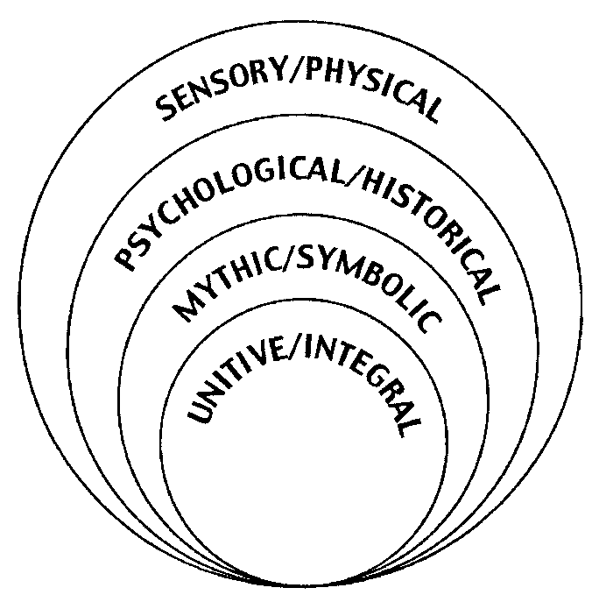

The sensory/physical level of social artistry leadership concerns the enhancement and activation of a leader’s senses especially of deep listening and visionary seeing but also of touch, taste and smell so as to be fully present to ones physical existence. This level includes the keen use of all the senses in relation to the natural and built environment, culture and individual and group behaviour. The psychological/historical level of social artistry leadership includes the deepening of individual and collective memory and emotion, personal psychological history, personal story, dream and reflection, both in the leader and those the leader serves. The mythic/symbolic level of social artistry leadership includes the use and powerful interpretation of myths, stories, heroes/heroines and symbols of culture and religion so as to motivate the society to reach its human development goals. The unitive/integral level of social artistry leadership includes the experience and mysterious awareness of the unity and interconnectedness of all of life, sense of oneness with others, self transcendence, spirituality, deep motivation, love and sense of calm and trust.

The third set of methods that is part of innovative leadership is the Technology of Participation or ToP. This array of effective leadership methods was developed by the Institute of Cultural Affairs (ICA) with which the author worked for 21 years. ToP includes, among others, methods of effective group discussion, group workshops and strategic planning.

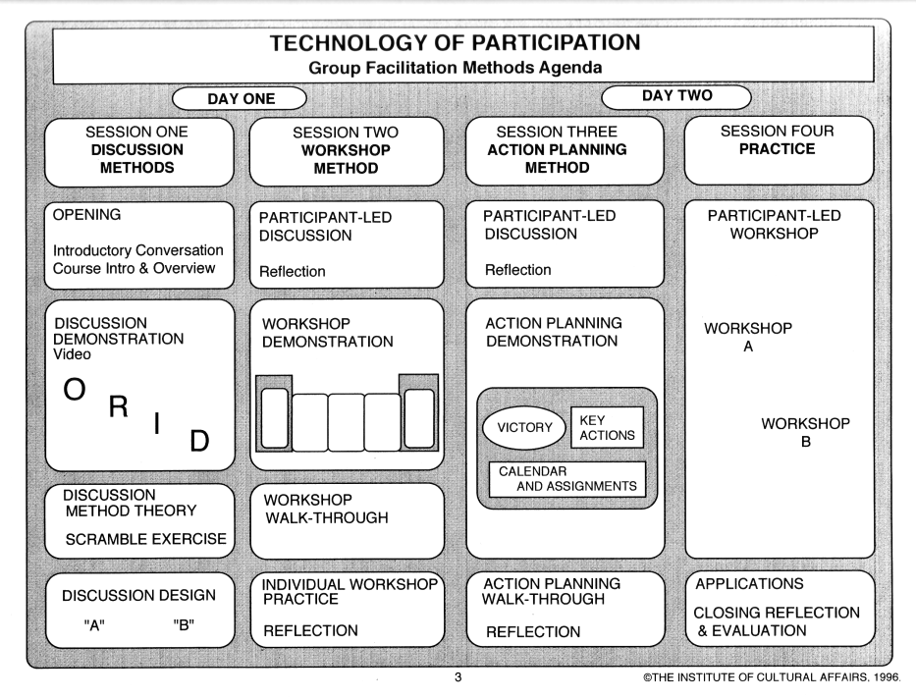

The ORID group conversation method takes people on a four part journey from Observation (what do you notice about the topic?), to Reflection (what are your associations and feelings about this?), to Interpretation (what does this mean to you?), and finally to the Decisional (what relationship do you decide to take to this?) concerning what to do because of the discussion.

The ToP workshop method includes six steps: 1) deciding the rational and experiential objectives, 2) setting the context, 3) brainstorming, 4) grouping of data, 5) naming of clusters of data and 6) reflecting on the group’s consensus.

The ToP strategic planning process uses the workshop method for each step and enables a community or organization to 1) articulate the shared vision of their hoped-for future, 2) analyze what could block or enable that vision, 3) create broad strategic directions to achieve the vision, 4) identify tactical systems to achieve the strategies, and 5) decide what discrete actions or implementaries in what timeframe will do the job.

These are only three of many, many innovative leadership approaches that have been effectively applied around the world with governments, NGOs, local communities and corporations. If made further use of in public service, public administration and governance over the coming years, they can have profound results both for the individual leader her/himself and for those with whom she/he works and serves as a leader. If a designated or elected leader makes use of these types of innovative methods, whole organizations, institutions and communities will begin to mirror and emulate the leader’s own awareness and prowess creating a powerful multiplying effect throughout the society. Can you imagine the use of any of these leadership approaches in a cabinet meeting or a parliament and what a difference they could make?

**IV. Thematic Discussion** **and Action**

Let us look at four thematic areas related to leadership:

1. Leading with integrity and inventiveness in public governance

2. Engaging citizens and civil society organizations to promote effectiveness,

accountability and transparency in reconstruction and recovery strategies after

nature disasters

3. E-leadership capacity development

4. Leading innovations in gender-responsible service delivery

With a social philosophy inspired by the Universal Declaration of Human Rights and in light of the challenges and opportunities of this Critical Decade, these themes provide an opportunity to articulate new pathways of transformative leadership and innovative governance. These pathways will in turn help clarify social discourse about future global, national and local scenarios and inspire people around the world to do what is needed at this moment in history to bring into being a new civilization of sustainable human development.

These four themes taken together identify and delineate a new style and practice of leadership and governance that embodies integrity, creativity, participation of all the people in a society, gender equity and use of information and communication technology and social networking. This is what is meant by transformative leadership - leadership that can respond effectively and profoundly to the multitude of challenges facing humanity at this critical moment and facilitate the creation of a new civilization.

Transformative leadership moves a society from a problem-solving mode to a whole systems design mode. It helps transform individual mindsets, values and behaviour, and collective culture and institutions. The transformative leader is deeply concerned and committed to creating the conditions in a society that enable each woman, man and child to realize her/his full potential. Transformative leadership makes use of participatory, interactive methods to ensure that each person’s voice and wisdom is heard and felt in social dialogue and policy making.

The transformative leader is a social artist and makes use of myths, stories, rituals, symbols and metaphors to motivate the society to imagine and reach its future vision. Transformative leadership makes use of the very latest information technologies to enable the population to participate in governance processes at every level. The transformative leader is a person of deep personal integrity and empathy who manifests compassion for other people. He/she is committed to being the servant of the people in helping everyone to live well and to die well. Transformative leadership is responsive to present and potential danger and disasters and helps prepare and engage the population in doing what is needed to avert and deal with natural disasters such as climate chaos and human-made suffering such as armed conflict. The transformative leader has a profound belief in universal human rights and is a powerful advocate for the empowerment of women, minorities, elders and youth.

Transformative leadership works to create strong democratic institutions and processes of governance. If transformative leadership were found in legislatures, executive offices, bureaucracies, courts, electoral commissions, NGOs and corporations, what a transformation we would see in the larger society! The transformative leader does everything in her/his power to help make a better life for all the people. In order to do this, he/she manages her/his ego, pride, greed, fear, anger and hatred and practices concern for and understanding toward all people.

How do we each work in our own countries, organizations and communities with renewed vision and practical tools for the betterment of their societies? How do we stay networked electronically and continue to challenge and encourage each other? How can we make use of new methods of leadership and help create new institutions of participatory governance? How can we design new systems and structures, as well as new policies, programmes and projects that will put into practice these insights?

**Concluding Questions**

What if we are in the midst of a turning point in human history - from despair to hope, from greed to compassion, from impoverishment to empowerment? What if we are indeed the people that the world has been waiting for? What if we are the catalysts and servants that history requires at this time? What if we are able to mobilize people in such a way as to respond to climate chaos, increasing poverty, the HIV/AIDS pandemic, gender-inequality and economic collapse? What if we embody integrity, creativity, effectiveness, accountability and transparency in everything we say and do?

What if we are the transformative leaders who call our fellow and sister citizens to join us in the greatest and noblest of tasks – to Build the Earth - to create a New Civilization - to catalyze Sustainable Human Development? What if these are indeed the times and we are indeed the people?

…………………………

References:

Houston, Jean. Jump Time: Shaping Your Future in a World of Radical Change. New

York: Tarcher/Putnam, 2001

Wilber, Ken. A Brief History of Everything. Melbourne; Hill of Content, 1996

Work, Robertson. “Civil society innovations in governance leadership: International

demonstrations of integral development, the technology of participation and

social artistry.” pp 112-131. Engaging Civil Society. Cheema and Popovski, Ed.

Tokyo: UN University Press, 2010

Websites:

Innovative Leadership Services. [www.innovativeleader.org](http://www.innovativeleader.org)

Institute of Cultural Affairs. [www.ica-international.org](http://www.ica-international.org)

Integral Institute. [www.integralinstitute.org](http://www.integralinstitute.org)

Jean Houston Foundation. [www.jeanhoustonfoundation.org](http://www.jeanhoustonfoundation.org)

(This chapter is based on a paper prepared by the author for UNDESA’s Global Forum on Transformative Leadership, June 2011, Dar es Salaam, Tanzania)